Supplementary Information
Wind-farm array orientation strongly shapes migratory-bird collision exposure with little energy loss
— A geometric exposure screen of Western European offshore and onshore wind farms
This document is the Supplementary Information for the main paper. It provides (i) the analytical methods — the geometric-exposure model, the five orientation metrics and the energy–ecology trade-off definition (S1); (ii) the data sources and underlying basic data, including the full specification of the onshore Jensen wake model and the offshore FLORIS setup that are summarised only briefly in the main text (S2); (iii) the ecological premise of the geometric-exposure analysis — migratory abundance, flight height and direction (S3); (iv) the cross-source universality of orientation sensitivity (S4); (v) consolidated core metrics for results R1–R4 (S5); (vi) the energy–ecology trade-off across annual-energy-production (AEP) budgets (S6); (vii) the robustness of the wake and directional assumptions together with a series of extended sensitivity analyses (S7, including the single-factor overview S7.0, the sampling-uncertainty analysis S7.14 and the default-value / regional / budget / concentration-weighting extensions S7.16–S7.19); a supplementary figure atlas (S8); and a scope-and-assumptions ledger (S9). All values are taken from the main text and the project data files; no data beyond the main text are introduced. Methodological details that the main text could not expand on (the Jensen wake-model parameterisation, the FLORIS setup, and the DBSCAN/PCA pipeline) are given here in fully reproducible form, together with a notation table (S1.0), a consolidated model-parameter table (S2.6) and the mathematical properties of the geometric model (S1.5).
Contents: S1 Analytical methods (notation S1.0, mathematical properties S1.5) | S2 Data sources and underlying basic data (parameter summary S2.6) | S3 Migratory-bird threat: abundance, altitude and direction | S4 Cross-source universality of directional sensitivity | S5 Consolidated core metrics (R1–R4) | S6 Energy–ecology trade-off across AEP budgets | S7 Robustness and sensitivity of the wake and directional assumptions (overview S7.0, S7.1–S7.14) | S8 Supplementary figures | S9 Scope-and-assumptions ledger | Data and code availability | Supplementary References
Main text ↔ Supplementary Information cross-reference (reading guide)
The table below maps each main-text (v7) figure, table and equation — and each supplementary figure the main text cites — to its location in this Supplementary Information, for cross-navigation. The numbering here has been aligned with the main text: the “Supplementary Fig. S1” cited in the main text (migratory-bird threat altitude overlap) is Figure S1 here, and the “Supplementary Fig. S2a/S2b” (cross-source universality) is Figure S2a / S2b here.
Main-text (v7) ↔ Supplementary Information cross-reference table (reading guide).
Main-text label | Main-text content | Location here
Fig. 1 (a–f) | Mechanism and regional evidence (dual-optimum comparison, exposure surface, geometric schematic, orientation histogram, study-area overview) | Fig. S3, S4, S8.6, S8.9
Fig. 2 (a–f) | Migratory direction structure and cross-source orientation sensitivity | Fig. S1, S2a, S8.6, S8.9
Fig. 3 (a–e) | Systematic misalignment of AEP-optimal and eco-optimal orientations | Fig. S3, S8.6, S8.2
Fig. 4 (a–f) | A finite rotation captures most of the avoidable exposure | Fig. S6, S7.7, S8.4, S7.5
Fig. 5 (a–i) | Energy–exposure trade-off (most ecological benefit within 1% AEP) | Fig. S6, S8.2, S8.7, S8.8
Table 1 | Five core concepts, definitions and units | Table S0, S1.2
Table 2 | Three-group × four-budget RR(%) medians (replaced by Fig. 5i in main text) | Table S5, Fig. S6
Table 3 | Data sources, scale and use | Table S1, S2, S3
Eq. (1) | Geometric-exposure model E(θ) (equal two-season weight) | S1.1 (incl. concentration-weighted generalisation)
Eq. (2) | sin²(0°)=0, sin²(90°)=1 boundary values | S1.1
Eq. (3) | Directional-sensitivity amplitude rel | S1.2
Eq. (4) | Avoidable-exposure fraction avoid | S1.2
Eq. (5) | Exposure ratio E(θ_econ)/E_min | S1.2
Eq. (6) | Energy-optimal orientation θ_econ | S1.3
Eq. (7) | Eco-optimal orientation θ_eco (AEP constraint) | S1.3
Eq. (8) | AEP cost | S1.3
Eq. (9) | Exposure reduction RR | S1.3
Supplementary Fig. S1 | Threat altitude overlap (main-text para 33) | Fig. S1
Supplementary Fig. S2a/S2b | Cross-source universality (main-text paras 37–38) | Fig. S2a / Fig. S2b

Supplementary Section S1 — Analytical methods
S1.0 Notation and symbols
For ease of reading, Table S0 collects every symbol and notation used in this Supplementary Information. θ is the array orientation (decision variable, 0–180°), φ_spring/φ_autumn are the spring/autumn dominant migratory flight directions, and c_spring/c_autumn the corresponding directional concentrations. The model and metric symbols follow the main-text convention and are not redefined one by one there.
Table S0 | Notation and symbols.
Symbol | Meaning
θ | Array orientation (0–180°, 180°-periodic)
φ_spring / φ_autumn | Spring/autumn dominant migratory flight direction
c_spring / c_autumn | Spring/autumn directional concentration
E(θ) | Geometric collision-exposure model (screening quantity, dimensionless 0–1)
E_min / E_max | Minimum/maximum exposure over θ
rel | Directional sensitivity amplitude = (E_max − E_min)/E_max
avoid | Avoidable exposure fraction = 1 − E_min/E(θ_econ)
E(θ_econ)/E_min | Exposure ratio (energy-optimal exposure vs minimum)
θ_econ / θ_eco | Energy-optimal orientation / ecology-optimal orientation under an AEP budget
Δθ / Δθ50 / Δθ80 | Ecological adjustment angle / minimum rotation for 50%/80% of max avoidable exposure
frac_d | Fraction of max avoidable exposure recovered by rotating d° from θ_econ
RR | Exposure reduction = [E(θ_econ) − E(θ_eco)]/E(θ_econ) × 100%
AEP(θ) | Annual energy production at orientation θ
AEP cost | Actual AEP loss / AEP_max
budget | Allowed AEP-loss budget (0.5%/1%/2%/5%)
α | Jensen wake-decay constant (0.075)
Ct | Thrust coefficient (0.80 below rated)
Cp,max | Maximum power coefficient (0.45)
ρ | Air density (1.225 kg/m³)
r / x | Rotor radius / downstream distance
A / k | Weibull scale / shape parameter
eps / min_samples | DBSCAN neighbourhood radius (3 km) / minimum samples (2)
n | Sample size (4,191 / 29 / 26)

S1.1 Geometric-exposure model
The geometric-exposure model relates the array orientation θ (0–180°) to the spring and autumn migratory flight directions φ_spring and φ_autumn as $E\left(θ\right) = 0.5 × \left[\sin^{2}\left(θ − φ_{spring}\right) + \sin^{2}\left(θ − φ_{autumn}\right)\right]$. When the array is parallel to the migration axis, $\sin^{2}\left(0°\right) = 0$ and birds pass along the inter-row corridors with minimal exposure; when perpendicular, $\sin^{2}\left(90°\right) = 1$ and birds cross the rotor-swept plane once per row, giving maximal exposure. The function uses sin² rather than sin so that exposure is likewise zero when orientation and direction differ by 180° — an array facing northeast and one facing southwest are equivalent for migrating birds — hence the model is 180°-periodic.
Geometrically, sin²(θ − φ) is equivalent to the square of the relative length of the array projected onto the normal to the migration axis: when the array forms an angle δ with the migration axis, the number of rotor rows a bird crosses is proportional to sin δ (the array's projection onto the axis normal), and the collision exposure of each row is in turn proportional to that projection, so the total exposure ∝ sin² δ. This square relation makes exposure a second-order stationary point near the axis (dE/dδ → 0 as δ → 0): exposure barely increases when the orientation deviates from optimal by only a few degrees — the geometric origin of the fact that a finite rotation recovers most of the avoidable exposure. Conversely, at orientations far from the axis, exposure falls nearly linearly with rotation, so a small rotation away from a high-exposure orientation buys a large reduction.
The model outputs geometric exposure (a screening quantity) without flight-height, avoidance or mortality calibration, and is not a measured collision-mortality reduction; the offshore VPTS/Bauer models additionally incorporate flux and flight height, moving closer to collision exposure but still without mortality calibration. Onshore and offshore exposure values are therefore not directly comparable in absolute terms, and the main text compares only the cross-orientation relative change. The boundary values are set by geometry alone and do not depend on any behavioural assumption, which is the source of the model's robustness as a screening tool.
Onshore, where directional concentration is available from the matched Bauer grid cell, the two seasons are weighted by their directional concentrations c_spring and c_autumn rather than equally: $E\left(θ\right) = \frac{\left[c_{spring}·\sin^{2}\left(θ − φ_{spring}\right) + c_{autumn}·\sin^{2}\left(θ − φ_{autumn}\right)\right]}{\left(c_{spring} + c_{autumn}\right)}$, so that a season with more tightly clustered migration contributes more to the directional exposure; when the concentrations are missing, the model falls back to equal 0.5/0.5 weighting. S7.5 shows that this weighting has almost no effect on the core results.
S1.2 Five orientation metrics
Each farm is summarised by five metrics, each answering one specific question about how orientation modulates exposure. The directional sensitivity amplitude $rel = \frac{E_{max} − E_{min}}{E_{max}}$ answers 'how large is the relative exposure change achievable by rotation alone'; the avoidable exposure fraction $avoid = 1 − \frac{E_{min}}{E\left(θ_{econ}\right)}$ answers 'how much exposure can be removed by re-orienting from the energy-optimal orientation'; the exposure ratio $\frac{E\left(θ_{econ}\right)}{E_{min}}$ answers 'how many times the energy-optimal exposure exceeds the achievable minimum'; the ecological adjustment angle Δθ is the minimum rotation from the energy-optimal to the ecology-optimal orientation, with the variants Δθ50/Δθ80 giving the minimum rotation required to capture 50%/80% of the maximum avoidable exposure, answering 'how large a rotation is needed to see an effect'; the capture fraction frac_d is the fraction of the maximum avoidable exposure recovered by rotating d° from θ_econ. Together the five metrics characterise the full spectrum of 'sensitivity – avoidability – rotation cost – early gain'.
In decision terms, rel and avoid answer 'whether' (is orientation relevant at all, and how much exposure can be removed), $\frac{E\left(θ_{econ}\right)}{E_{min}}$ answers 'the cost of inaction' (the factor by which exposure exceeds the minimum when the energy-optimal orientation is retained), and the Δθ series with frac_d answer 'how cheap and how fast' (how large a rotation is needed, and how much gain each degree of rotation recovers). These three correspond respectively to the 'potential – inertia – cost' dimensions of siting decisions, on which the main text organises the results as R1–R4.
S1.3 Energy–ecology trade-off definition
$θ_{econ} = argmax AEP\left(θ\right)$ is the energy-optimal orientation; $θ_{eco} = argmin E\left(θ\right)$ subject to $AEP\left(θ\right) ≥ (1 − budget) × AEP\left(θ_{econ}\right)$ is the ecology-optimal orientation under an AEP-loss budget. The AEP cost is the actual loss divided by AEP_max, and the exposure reduction is $RR = \frac{\left[E\left(θ_{econ}\right) − E\left(θ_{eco}\right)\right]}{E\left(θ_{econ}\right)} × 100\%$. Four budgets are used — 0.5%, 1%, 2% and 5% — corresponding to low-cost, balanced, protection-priority and maximal scenarios. The core question the trade-off analysis answers is: how much exposure can be removed by re-orientation while sacrificing almost no generation. Figure S3 illustrates the geometric structure of this trade-off for a representative onshore farm.
S1.4 Data and AEP computation (summary)
Offshore: 171 wind farms carry engineering-grade AEP–orientation curves from FLORIS wake simulations at 18 orientation angles (0–170°, 10° step); 55 of them have measured migratory-bird direction (29 from VPTS weather radar, 26 from the Bauer grid). Onshore: OpenStreetMap Overpass API supplies 100,327 turbine coordinates; DBSCAN clustering (eps = 3 km) and PCA principal-axis extraction yield 5,954 farms (mean PCA explained-variance ratio 87.7%); after dropping micro/vertical-axis machines (hub or rotor diameter < 20 m), 5,869 farms remain. Wind resource comes from Global Wind Atlas Weibull parameters (log-wind-profile interpolated to hub height), and AEP is computed with the analytic Jensen wake model (decay constant α = 0.075, multi-wake RSS superposition) over 59 wind-speed bins and 36 inflow directions at 10° resolution, scanning 18 orientations. Of the 5,869 farms with AEP, 4,191 fall within the Bauer bird-direction coverage and enter the trade-off analysis; the remaining 1,678 (mostly Great Britain/Ireland, Northern Europe/Baltic and the Iberian Peninsula) are excluded as out of coverage. Section S2.3 gives the full model specification.
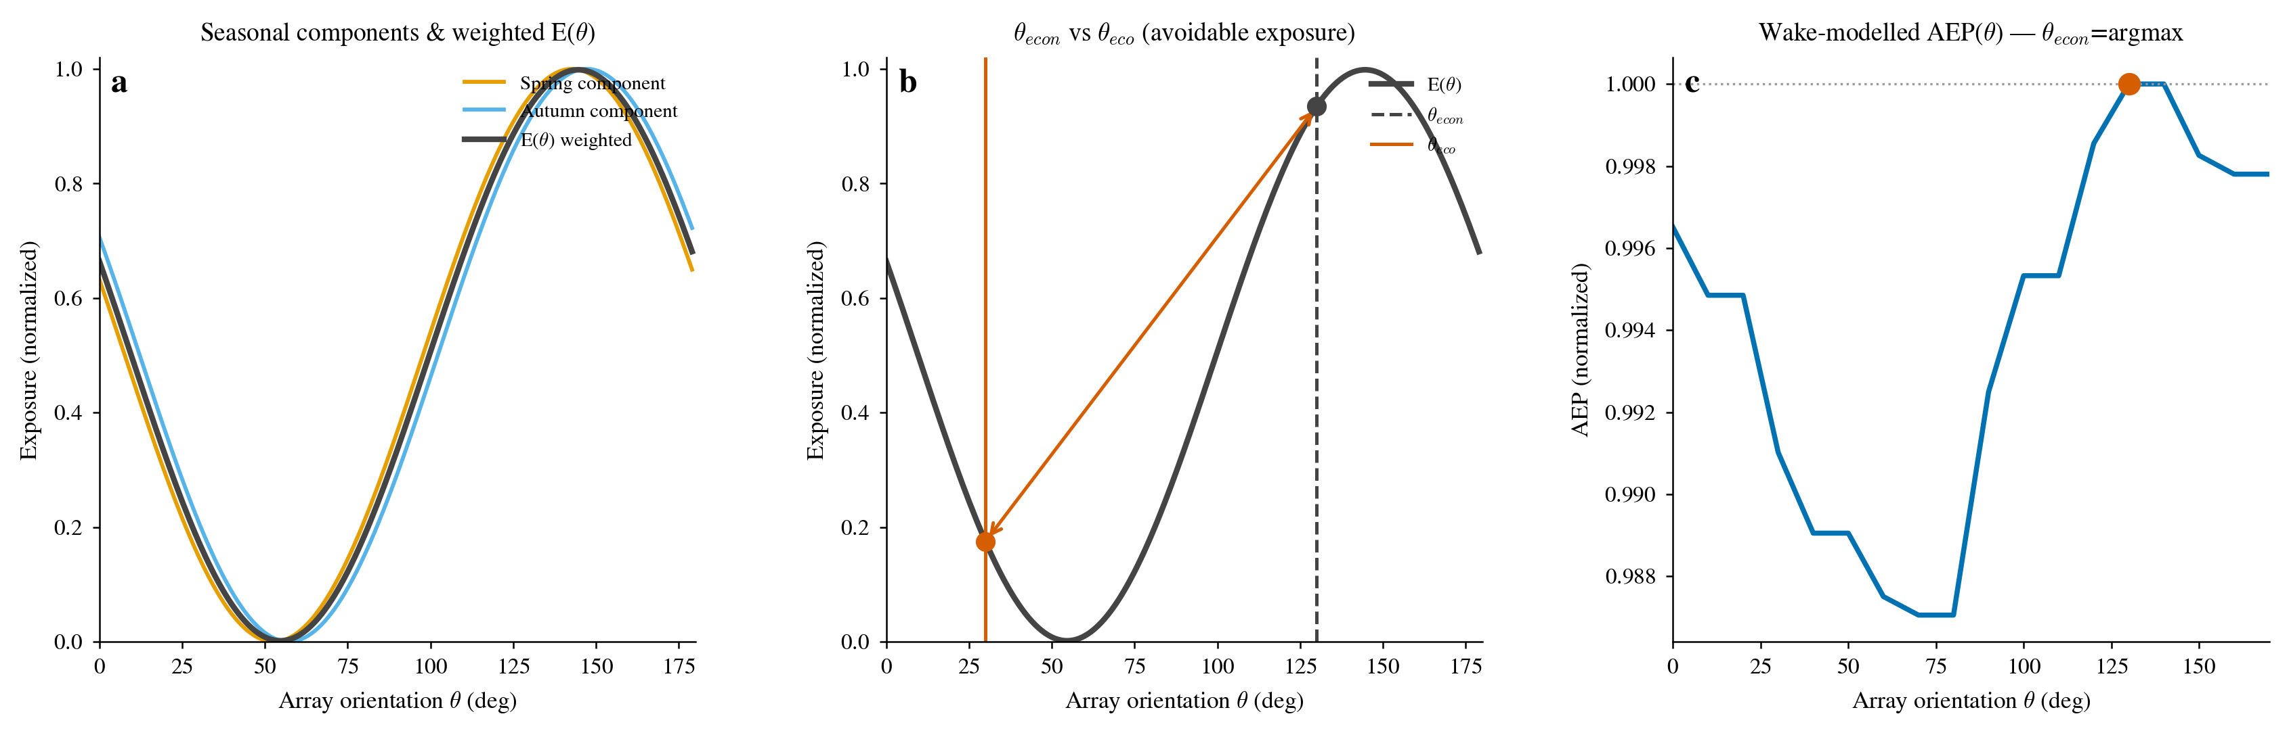
Figure S3 | Geometric-exposure model and energy–ecology trade-off. (a) Spring/autumn sin² components and the concentration-weighted exposure curve E(θ); (b) the energy-optimal orientation θ_econ and ecology-optimal orientation θ_eco with the avoidable-exposure region (double arrow); (c) the wake-model AEP(θ) polar, θ_econ = argmax AEP(θ).
S1.5 Mathematical properties of the geometric-exposure model
The following properties depend on no behavioural or empirical parameter, being set by the geometry alone, and are the source of the model's robustness as a screening tool.
Property 1 (180°-periodicity). $\sin^{2}\left(x + 180°\right) = \sin^{2}x$, hence $E\left(θ + 180°\right) = E\left(θ\right)$. An array facing northeast and one facing southwest are equivalent for migrating birds, so the model is defined on the 180° circle with θ ranging over 0–180°.
Property 2 (projection-square equivalence). sin²(θ − φ) equals the square of the relative length of the array projected onto the normal to the migration axis. The number of rotor rows a bird crosses is proportional to |sin(θ − φ)| (the array's projection onto the axis normal), and the collision exposure of each row is in turn proportional to the same projection, so the total exposure ∝ sin²(θ − φ). This square relation makes the 'projection-square' statement of S1.1 strictly equivalent to the sin² model.
Property 3 (second-order stationarity at the optimum). $\frac{dE}{dθ} ∝ sin\left(2(θ − φ)\right)$, so at θ = φ the first derivative vanishes and the second derivative $\frac{d^{2}E}{dθ^{2}} ∝ 2cos\left(2(θ − φ)\right) = +2 > 0$, making E a second-order minimum near the optimum: $E\left(θ\right) ≈ {\left(θ − φ\right)}^{2}$. Exposure barely increases when the orientation deviates from optimal by only a few degrees; conversely, at orientations far from the axis, exposure falls nearly linearly with rotation. This 'flat near, steep far' curvature structure is precisely the geometric origin of the fact that a finite rotation recovers most of the avoidable exposure (Δθ50 of only 14–18° in S5).
Property 4 (normalisation of the concentration weighting). The concentration-weighted model $E\left(θ\right) = \frac{\left[c_{spring}·\sin^{2}\left(θ − φ_{spring}\right) + c_{autumn}·\sin^{2}\left(θ − φ_{autumn}\right)\right]}{\left(c_{spring} + c_{autumn}\right)}$ is a convex combination of two unit-amplitude sin² terms, so $0 ≤ E\left(θ\right) ≤ 1$, with E = 0 if and only if both terms vanish; when c_spring = c_autumn it reduces to equal 0.5/0.5 weighting. The normalisation guarantees dimensionless comparability, and S7.5 shows that the weighting has almost no effect on the core results.
Property 5 (budget monotonicity and saturation). The feasible set {θ : AEP(θ) ≥ (1 − budget)·AEP_max} grows monotonically with budget, so RR(budget) is non-decreasing in budget and tends to the unconstrained maximum as the budget spans the whole AEP range. This explains the 'small budget reaches saturation' pattern of S6 — a 1% budget already delivers a 96.9% onshore median reduction, with very small marginal gain from 2% to 5%.
Property 6 (single-orientation suppression under anti-parallel seasons). When the two seasonal directions are nearly anti-parallel ($φ_{autumn} ≈ φ_{spring} + 180°$, directional difference ≈183° here), $\sin^{2}\left(θ − φ_{autumn}\right) = \sin^{2}\left(θ − φ_{spring} − 180°\right) = \sin^{2}\left(θ − φ_{spring}\right)$, so the two seasonal components become one and the same function and a single array orientation minimises both simultaneously — spring and autumn do not impose a mutually constraining trade-off (consistent with the direction structure of S3).
S1.6 Worked example: one representative onshore farm
To show how the quantities of S1.1–S1.3 are computed from raw inputs, this section gives a complete worked example. We select farm 1986 (in the Ore Mountains of eastern Germany, 50.749°N, 13.133°E, 4 turbines), because its exposure reduction under the 1% AEP budget (96.9%) is exactly the median over the 4,191 farms, so it serves as a “typical” case. Its matched Bauer grid cell is 8.4 km away and gives the two seasonal dominant directions and concentrations: φ_spring = 47.2°, φ_autumn = 227.6°, c_spring = 0.877, c_autumn = 0.784.
Substituting into the concentration-weighted model $E\left(θ\right) = \frac{\left[c_{spring}·\sin^{2}\left(θ − φ_{spring}\right) + c_{autumn}·\sin^{2}\left(θ − φ_{autumn}\right)\right]}{\left(c_{spring} + c_{autumn}\right)}$ (φ_spring = 47.2°, φ_autumn = 227.6°, c_spring = 0.877, c_autumn = 0.784; denominator c_spring + c_autumn = 1.661) and evaluating pointwise gives the table below (θ in 15° steps; a finer 1° scan gives E_min ≈ 5.8×10⁻⁵ at θ ≈ 47°, essentially coincident with the spring principal axis at 47.2°).
Table S1a | Geometric-exposure curve E(θ) of the representative onshore farm (farm 1986), concentration-weighted, θ in 15° steps.
θ (°) | E(θ)
0 | 0.5416
15 | 0.2869
30 | 0.0893
45 | 0.0017
60 | 0.0477
75 | 0.2148
90 | 0.4584
105 | 0.7131
120 | 0.9107
135 | 0.9983
150 | 0.9523
165 | 0.7852
180 | 0.5416

The curve reaches its minimum E_min ≈ 5.8×10⁻⁵ at θ ≈ 47° (≈ the spring principal axis) and its maximum E_max ≈ 0.9999 at θ ≈ 137° (perpendicular to the axis). The directional-sensitivity amplitude $rel = \frac{E_{max} − E_{min}}{E_{max}}$ = (0.9999 − 5.8×10⁻⁵)/0.9999 ≈ 99.99%; the avoidable-exposure fraction $avoid = 1 − \frac{E_{min}}{E\left(θ_{econ}\right)}$ = 1 − 5.8×10⁻⁵/0.542 ≈ 99.99% (with E(θ_econ = 0°) = 0.542). The exposure ratio $\frac{E\left(θ_{econ}\right)}{E_{min}}$ = 0.542/5.8×10⁻⁵ ≈ 9.3×10³ — far above the full-sample median (≈600×), because the two seasons here are almost exactly anti-parallel (180.4° apart), making E_min tiny; the exposure ratio is highly sensitive to E_min and varies widely across farms.
This farm's AEP-optimal orientation $θ_{econ} = argmax AEP\left(θ\right)$ is 0° (due north, aligned with the dominant wind resource); under the 1% AEP budget the eco-optimal orientation $θ_{eco} = argmin E\left(θ\right)$ is 40°, with an actual AEP loss of 0.95%, and exposure drops from E(0°) = 0.542 to E(40°) ≈ 0.017, an exposure reduction $RR = \frac{\left[E\left(θ_{econ}\right) − E\left(θ_{eco}\right)\right]}{E\left(θ_{econ}\right)} × 100\%$ = (0.542 − 0.017)/0.542 × 100% ≈ 96.9% — exactly the full-sample median. The four-budget results are:
Table S1b | Energy–ecology trade-off results of the representative onshore farm (farm 1986) across four AEP budgets.
AEP budget | θ_eco | Actual AEP loss | Exposure reduction RR
0.5% | 20° | 0.46% | 60.9%
1% | 40° | 0.95% | 96.9%
2% | 50° | 1.35% | 99.6%
5% | 50° | 1.35% | 99.6%

This example walks through every step of S1.1–S1.3: inputs (two seasonal directions and concentrations) → the E(θ) curve → the three orientation metrics (rel/avoid/exposure ratio) → the energy–ecology trade-off (θ_econ/θ_eco/RR/AEP cost). The RR values agree digit-for-digit with the farm-1986 records in onshore_tradeoff_results.csv (1% budget RR = 96.94%), confirming that the Supplementary text and the data files use one consistent convention.
S1.7 Offshore worked example: representative VPTS and Bauer farms
Offshore exposure curves are obtained from VPTS weather-radar (0–200 m rotor-layer signature) or Bauer-grid direction inputs through the parallel-corridor proxy curve, rather than the onshore analytic sin² form; but the energy–ecology trade-off mechanism is identical to onshore (θ_econ is given by AEP maximisation, θ_eco is the orientation that minimises exposure subject to the AEP budget, and RR is the relative exposure reduction from θ_econ to θ_eco). To illustrate this mechanism, we take two 'typical' farms: the VPTS-group median farm, farm 11 (Germany, 1% budget RR = 82.12%, exactly the VPTS group median), and the near-median Bauer farm, farm 49 (France, RR = 49.38%, Bauer group median 47.6%).
Table S1c | Energy–ecology trade-off worked example for two representative offshore farms (1% AEP budget). RR agrees digit-for-digit with tradeoff_offshore_55farms.csv.
Worked-example item | VPTS farm (farm 11) | Bauer farm (farm 49)
Spring direction φ_spring | 348.9° | 56.4°
Autumn direction φ_autumn | 251.8° | 248.8°
AEP-optimal orientation θ_econ | 10° | 160°
Eco-optimal at 1% budget θ_eco | 70° | 20°
Realised AEP loss | 0.865% | 0.188%
Exposure reduction RR | 82.12% | 49.38%

Both farms demonstrate the mechanism of 'a large exposure reduction for an AEP concession of <1%', but with different magnitudes: the VPTS farm exchanges a 0.865% AEP cost for an 82.12% exposure reduction, and the Bauer farm a 0.188% cost for 49.38%. This difference stems from the resolution difference between the two direction conventions (S7.4) — VPTS is a direct rotor-layer observation with sharper directions, whereas Bauer is grid-interpolated with more diffuse directions. Table S3b lists the complete per-farm offshore results.
Supplementary Section S2 — Data sources and underlying basic data
S2.1 Data source overview
Table S1 lists every data source used, its scale or coverage, and its role in the analysis. All sources are public; the Bauer 2026 migration-direction product is available from Zenodo (10.5281/zenodo.17960034), the VPTS radar data from the Royal Meteorological Institute of Belgium (KMI) open-data FTP, and the remaining sources as cited in the main text. The three bird-direction sources (VPTS radar, Bauer grid and ERA5 meteorology) are independent in kind; ERA5 is rejected on testing (S7.3).
Table S1 | Data sources, scale/coverage and use.
Data | Source | Scale / coverage | Use
Turbine coordinates | OpenStreetMap Overpass API | 100,327 turbines | Onshore farm construction
Wind resource | Global Wind Atlas | 12-sector Weibull (A, k), 6 heights | Onshore AEP
Turbine parameters | OSM tags + Bauer database | 58% tagged, remainder imputed | Power/thrust curves
Offshore farm direction | VPTS weather radar (KMI) | 29 farms, rotor-layer corrected | Offshore exposure
Offshore farm direction | Bauer 2026 migration grid | 26 farms | Offshore exposure
Onshore farm direction | Bauer 2026 migration grid | 4,191 farms, 200-km match | Onshore exposure
Meteorological wind | ERA5 reanalysis | — (rejected: 77–102° mean error) | Direction proxy test
Offshore AEP | FLORIS (NREL) | 171 farms × 18 angles | Offshore AEP
Global farm inventory | Global Energy Monitor | Global wind-power tracker | Farm inventory
Migration flyways | CAFF Arctic Migratory Birds Initiative | Coarse flyway partitions | Context
Site sensitivity | BirdLife AVISTEP + species data | — | Context

S2.2 Onshore farm construction and AEP pipeline
The onshore analysis proceeds in four steps, with the following counts.
(1) The OpenStreetMap Overpass API provides 100,327 individual turbine coordinates. Each carries attributes such as hub height, rotor diameter and rated capacity, but about 42% of the per-turbine attributes are missing and require later imputation.
(2) DBSCAN clustering (eps = 3 km, min_samples = 2) groups the turbines into 7,238 farm clusters (with a further 3,148 isolated turbines as noise); PCA principal-axis extraction drops 1,284 clusters containing only two turbines (too few to define a stable axis), leaving 5,954 farms — the min_samples = 3 stated in the main text corresponds to this effective '≥3 turbines' threshold. The mean PCA explained-variance ratio is 87.7% (S7.12), showing that a farm is well described by a single dominant orientation.
(3) Turbine parameters (hub height, rotor diameter, rated capacity) are read from OSM tags for ~58% of turbines, with missing values filled by the spatially nearest entry in the Bauer database; micro- and vertical-axis machines (hub height or rotor diameter < 20 m) are then dropped, leaving 5,869 farms.
(4) Jensen-model AEP(θ) curves are computed for these 5,869 farms (93,964 turbines), totalling about 547 TWh year⁻¹ at the optimal orientation (capacity factor 28.1%). Of these, 4,191 farms fall within the Bauer bird-direction coverage (43–55°N, 4.75°W–16°E, 200-km match radius) and enter the trade-off analysis, accounting for about 373 TWh; the remaining 1,678 farms are excluded. Per-farm AEP curves are stored in onshore_aep_curves.csv (aep_000…aep_170, 18 orientations).
S2.3 Onshore AEP: full Jensen wake-model specification
The main text summarises the onshore AEP computation in one sentence; the full specification is given here. The analytic Jensen (1983) wake model gives the single-wake velocity deficit at a downstream distance x behind a turbine of rotor radius r as $\frac{Δv}{v_{∞}} = \frac{1 − \sqrt{1 − C_{t}}}{{\left(1 + α·\frac{x}{r}\right)}^{2}}$, where α = 0.075 is the onshore wake-decay constant and Ct is the thrust coefficient; the wake radius grows linearly as $r_{wake}\left(x\right) = r + α·x$. Multiple wakes are combined with the root-sum-square (RSS) rule: the total squared deficit at a turbine is the sum of the squared deficits of all upstream wakes, and the effective wind speed is $v_{eff} = v_{∞} × \left(1 − \sqrt{Σ{deficit}^{2}}\right)$. Partial wake overlap is modelled by a linear ramp within the wake radius.
Turbine aerodynamics follow an IEC-style parameterisation. The power curve is cubic below rated wind speed (maximum power coefficient Cp,max = 0.45), constant at rated power above it, with cut-in 3 m/s and cut-out 25 m/s; the rated wind speed is derived from rotor diameter and rated power. The thrust coefficient is Ct = 0.80 below rated wind speed and Ct ∝ v⁻³ above rated (pitch regulation). Air density is ρ = 1.225 kg/m³.
Wind resource comes from Global Wind Atlas (GWA), which supplies 12-sector Weibull parameters (A, k) and sector frequencies at heights 10/50/100/150/200/250 m. A is interpolated log-linearly and k linearly to each farm's median hub height, at roughness class 0.400 m (typical European agricultural terrain). The no-wake energy is computed by integrating P(v) × Weibull(v | A, k) over 59 wind-speed bins (0.5–30 m/s, ΔV = 0.5 m/s). The wake efficiency is evaluated at four representative wind speeds (4/8/12/16 m/s) and weighted by the energy contribution P(v)·Weibull(v). The 12 GWA sector energies are distributed onto 36 inflow directions (10° resolution), each GWA sector centred on its 30° band spanning its three adjacent 10° bins. AEP(θ) is then computed for 18 orientations (0–170°, 10° step) as 8,760 h × Σ over the 36 wind directions of [sector energy × wake efficiency at (wind direction − θ)].
Missing per-farm parameters fall back to defaults of 70 m hub height, 70 m rotor diameter and 2 MW capacity only when neither OSM tags nor the Bauer database provide a value; missing per-turbine rotor diameters are filled with the farm median so that the wake radius is consistent with the power curve.
S2.4 Offshore AEP: FLORIS
Offshore AEP–orientation curves are engineering-grade results from the National Renewable Energy Laboratory (NREL) FLORIS wake model, computed in a preceding project stage, at 18 orientation angles (0–170°, 10° step) for 171 wind farms. Only 55 of these farms have measured migratory-bird direction (29 from VPTS radar, 26 from the Bauer grid) and therefore enter the exposure and trade-off analysis. The offshore orientation sensitivity is larger than the onshore one: AEP varies by a mean of about 8.8% across orientations under FLORIS, versus about 2.7% for the onshore Jensen model (see S7.13).
S2.5 Migratory-bird direction inputs
Offshore bird direction uses two independent measurements. VPTS weather radar (KMI open data FTP, corrected to the 0–200 m rotor layer) supplies direction, concentration and flux for 29 farms. The Bauer 2026 migration-direction grid (2,025 valid cells) supplies direction for 26 offshore farms. Onshore bird direction uses the same Bauer grid, matched to each farm centroid within a 200-km radius. The ERA5 meteorological wind direction is not usable as a bird-direction proxy: it differs from the measured bird direction by an average of 77–102°, with only 14–50% of observations within 30° (see S7.3). Table S3 lists the per-farm direction inputs for the 55 offshore farms.
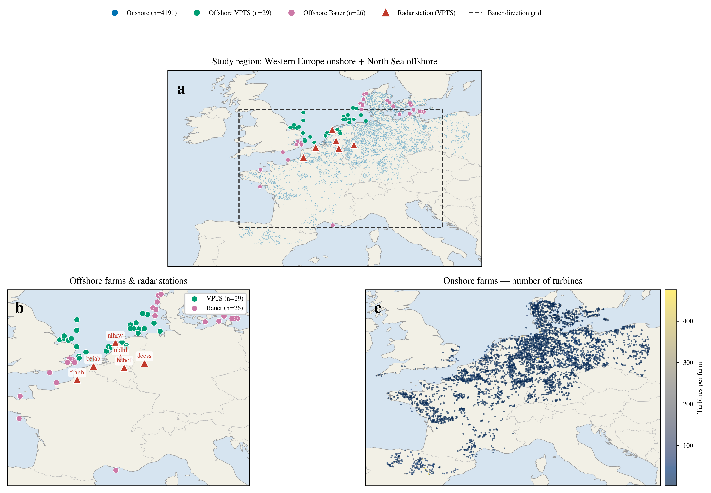
Figure S4 | Study-area overview and wind-farm distribution. (a) Western European onshore + North Sea offshore study area; (b) enlarged view of the 55 offshore farms (VPTS/Bauer) and radar stations; (c) onshore farms coloured by turbine count.
S2.6 Consolidated model-parameter table
Table S2a consolidates every model parameter used in the analysis, its adopted value, and (in the rightmost column) the subsection that tests its sensitivity. Parameters not tested in a subsection take physical or engineering convention values whose influence does not change the qualitative conclusion (see the S9 assumptions ledger).
Table S2a | Model parameters and adopted values (rightmost column lists the testing subsection; untested entries are engineering-convention values).
Parameter | Value | Tested in
Wake-decay constant α | 0.075 | S7.2
Thrust coefficient Ct | 0.80 below rated, ∝v⁻³ above | —
Maximum power coefficient Cp,max | 0.45 | —
Air density ρ | 1.225 kg/m³ | —
Cut-in / cut-out wind speed | 3 / 25 m/s | —
Wake orientation-penalty amplification | 1.0× (baseline) | S7.1
DBSCAN eps / min_samples | 3 km / 2 | S7.6
PCA principal axis | First principal component (PC1) | S7.12
Bauer match radius | 200 km | S7.7
Seasonal weighting | Directional-concentration weighting | S7.5
AEP budget levels | 0.5% / 1% / 2% / 5% | S6
GWA roughness class | 0.400 m | —
Wind-speed bins | 59 (0.5–30 m/s, ΔV = 0.5) | —
Inflow directions | 36 (10° resolution) | —
Orientation scan | 18 (0–170°, 10° step) | —

Supplementary Section S3 — Migratory-bird threat: abundance, altitude and direction
The migratory threat over the study region is quantifiable and substantial. VPTS weather radar records mean migration-season densities of 12–135 birds/km³ (spring 12–24, autumn 16–135), an instantaneous peak density of 1,287 birds/km³, and a maximum single-station autumn total flux of ≈825,000. Table S2 reports the underlying per-station, per-season basic data.
Table S2 | VPTS weather-radar station basic data, by season. Density in birds/km³; flux is the migration-season total; direction is the dominant flight direction (degrees, 0 = north, clockwise); concentration is the circular directional concentration. A dash marks a season with no directional observation at that station.
Station | Season | Mean density | Peak density | Total flux | Direction (°) | Concentration
deess | spring | 15.3 | 404.6 | 369,412 | — | —
deess | autumn | 16.1 | 142.8 | 561,019 | — | —
behel | spring | 11.6 | 15.6 | 616 | — | —
behel | autumn | — | — | 0 | — | —
bejab | spring | 16.0 | 223.7 | 174,575 | 8.9 | 0.176
bejab | autumn | 23.1 | 525.1 | 240,879 | 213.7 | 0.576
frabb | spring | 15.1 | 367.8 | 179,389 | — | —
frabb | autumn | 17.8 | 1,286.7 | 454,432 | 224.7 | 0.985
nlhrw | spring | 23.8 | 378.9 | 333,997 | 348.9 | 0.128
nlhrw | autumn | 54.1 | 969.1 | 825,486 | 251.8 | 0.323
nldhl | spring | — | — | 0 | — | —
nldhl | autumn | 134.9 | 934.8 | 60,570 | 56.1 | 0.962

Table S2 shows marked between-station differences. The four stations with directional observations (bejab, frabb, nlhrw, nldhl) have spring dominant directions concentrated in 8.9°–348.9° (northward) and autumn in 56.1°–251.8° (southward/southwestward); total flux spans about four orders of magnitude, from 616 in behel spring to 825,486 in nlhrw autumn; peak density reaches 1,287 birds/km³ (frabb autumn). The two stations deess and behel have low flux and no directional observation, reflecting their marginal position in the migration corridor. Overall, autumn flux and peak density are systematically higher than spring (most stations have autumn total flux about 1.4–2.5× the spring value), consistent with the European autumn migration carrying large numbers of first-year birds. This cross-station flux and altitude structure provides the quantifiable ecological premise for the subsequent geometric-exposure analysis.
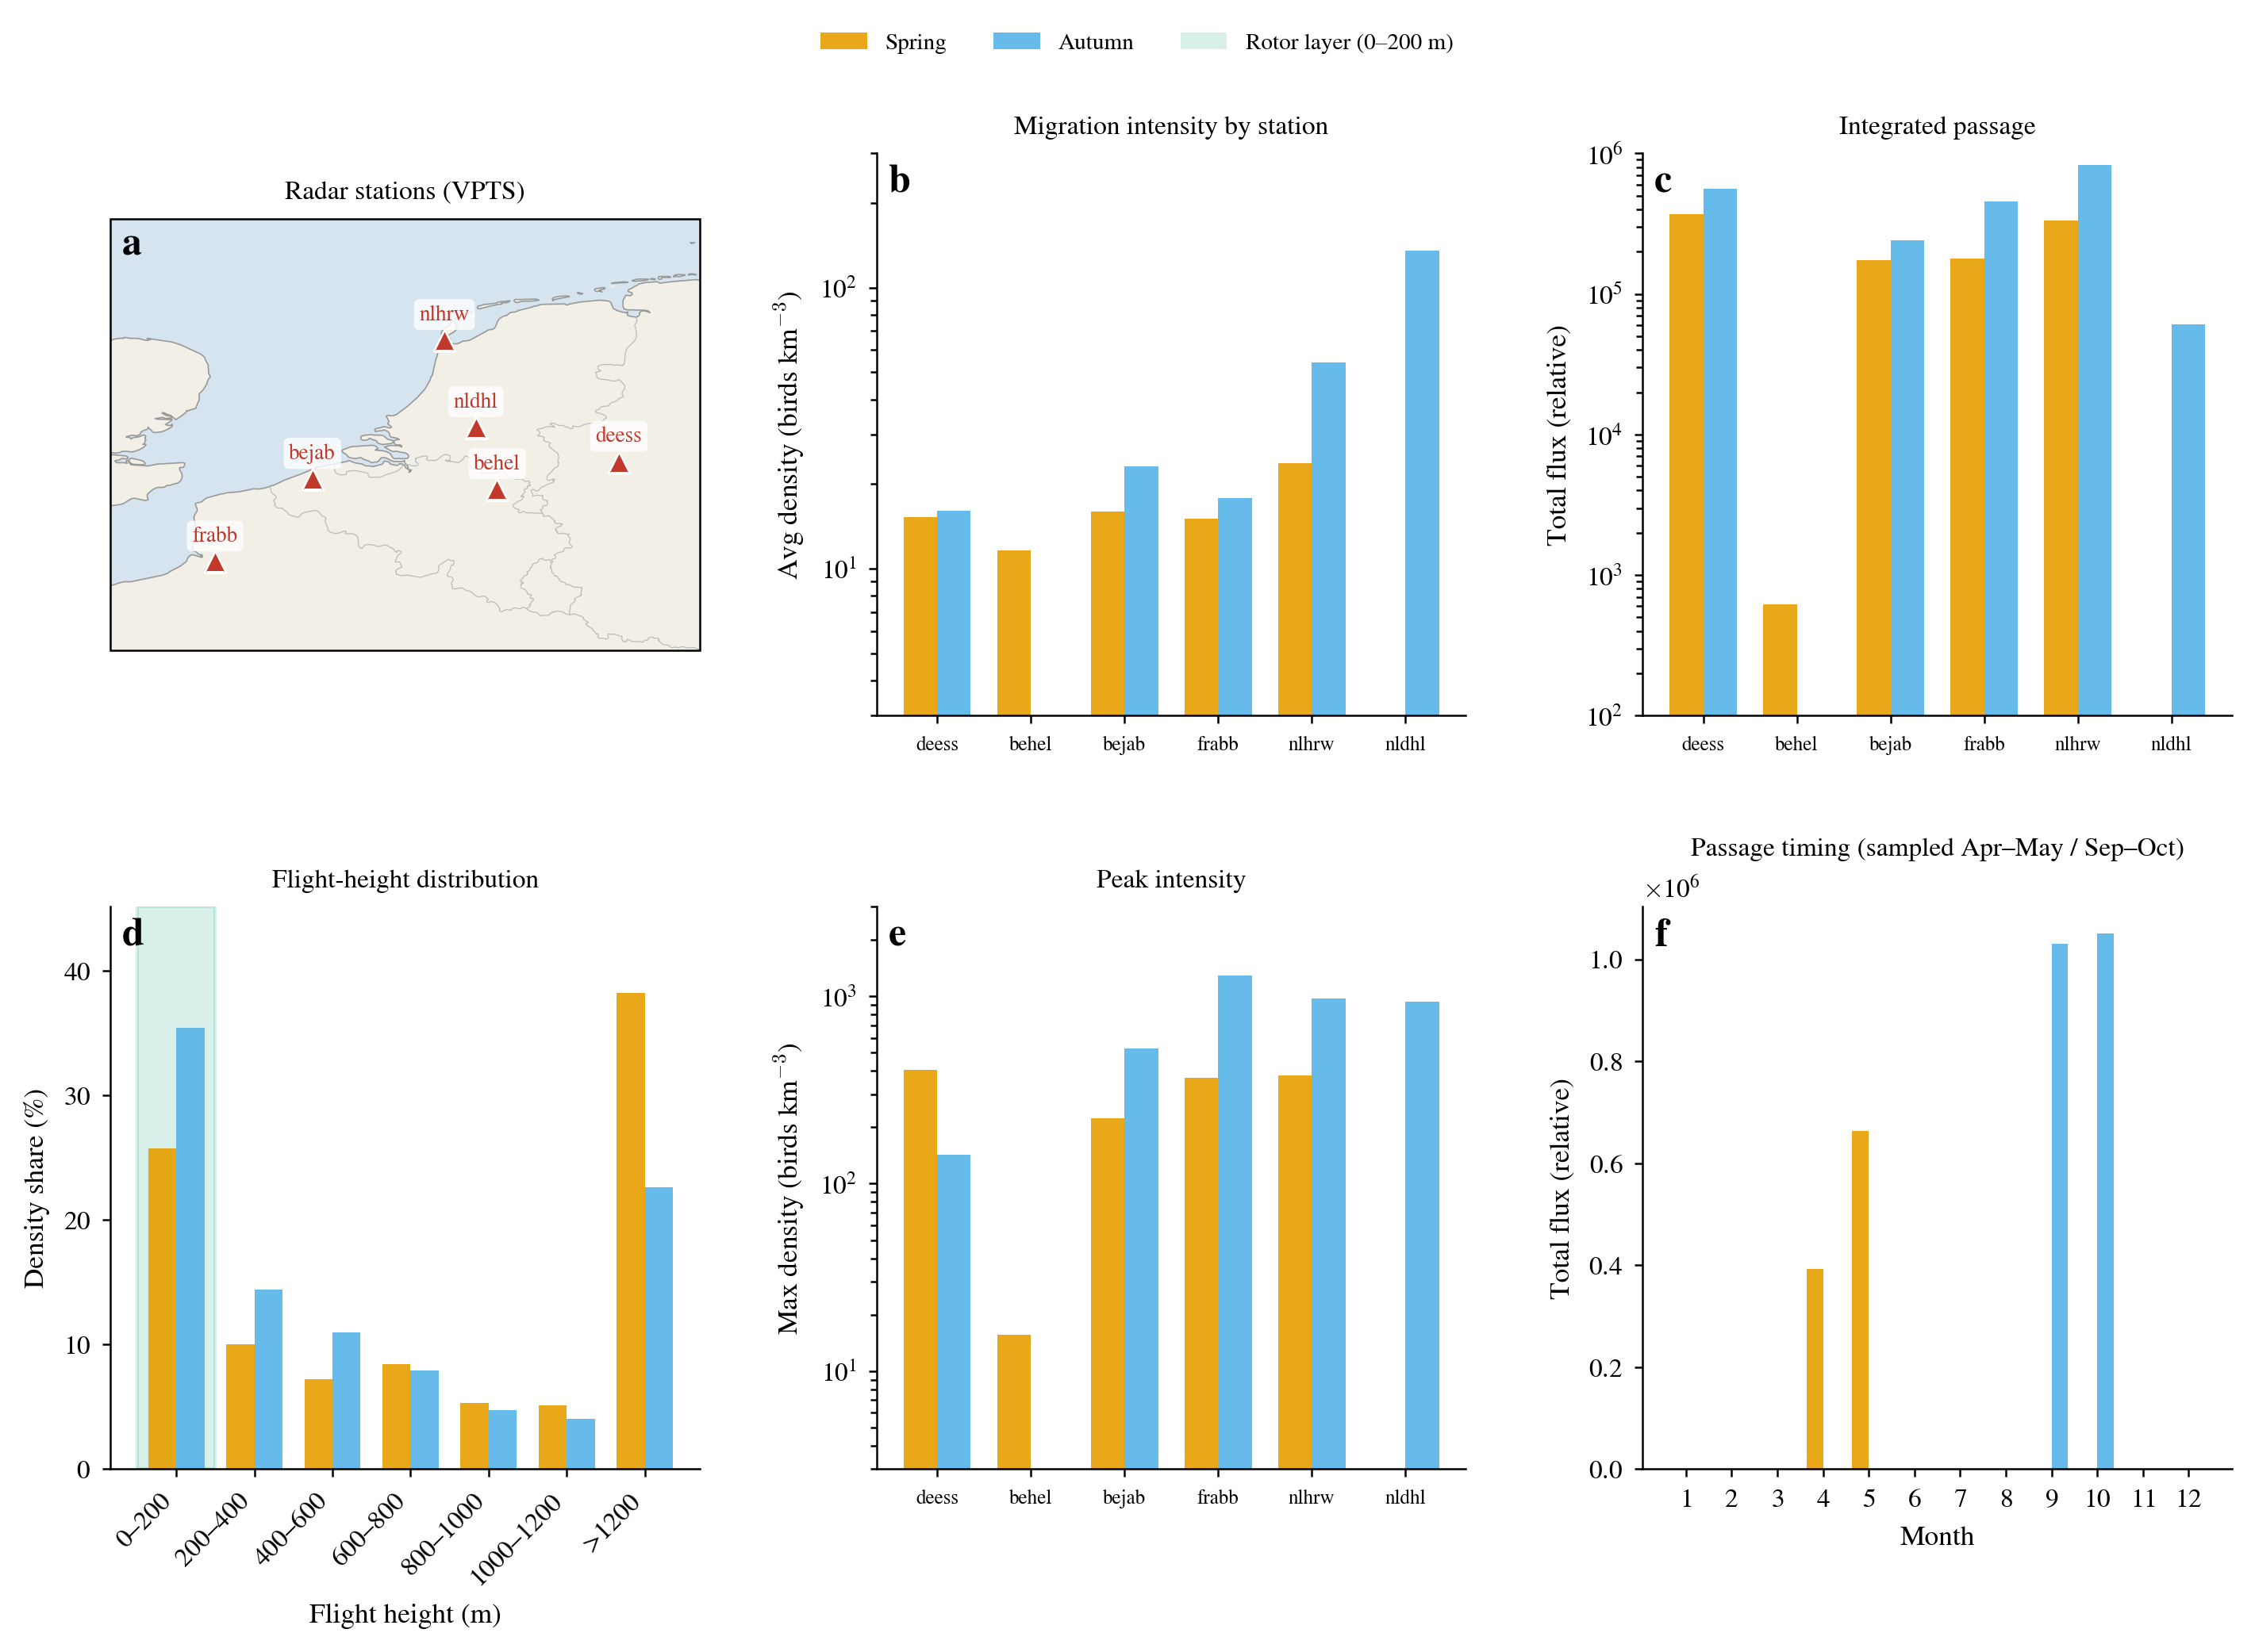
Figure S1 | Quantity, height and direction of the migratory-bird threat. (a) Positions of the radar stations (VPTS); (b) mean spring/autumn density of each station (log scale); (c) total migration-season flux of each station (log scale); (d) flight-height distribution (0–200 m rotor layer highlighted, ≈26%–35% of the total-height flux pooled, 0–71% per station); (e) peak density per station; (f) migration phenology (monthly). Migratory birds overlap the turbine rotor layer systematically in height, providing the ecological premise for the geometric-exposure analysis.
Beyond the radar-measured threat, the migration direction itself has stable structure. Across 2,025 valid Bauer grid cells, the median spring dominant direction is 51.5° (northeast) and the median autumn direction 234.9° (southwest); the median directional concentration is 0.89 in spring and 0.76 in autumn. The two seasonal vectors are nearly anti-parallel (directional difference ≈183°), but because exposure geometry is 180°-periodic the two seasonal axes differ by only ≈3.4°. A single array orientation can therefore suppress both seasonal exposures simultaneously — spring and autumn do not impose a mutually constraining trade-off. Table S3 lists the bird-direction inputs for the 55 offshore farms.
Table S3 | Per-farm migratory-bird direction inputs for the 55 offshore farms (VPTS 29 + Bauer 26). Direction is the dominant migratory flight direction (degrees, 0 = north, clockwise).
No. | farm_id | Country | Source | Spring direction (°) | Autumn direction (°)
1 | 2 | Belgium | VPTS | 8.9 | 213.7
2 | 5 | United Kingdom | VPTS | 8.9 | 213.7
3 | 7 | Netherlands | VPTS | 348.9 | 251.8
4 | 11 | Germany | VPTS | 348.9 | 251.8
5 | 15 | Netherlands | VPTS | 348.9 | 251.8
6 | 16 | Netherlands | VPTS | 348.9 | 251.8
7 | 18 | Germany | VPTS | 348.9 | 251.8
8 | 20 | Netherlands | VPTS | 348.9 | 251.8
9 | 23 | Netherlands | VPTS | 348.9 | 251.8
10 | 26 | United Kingdom | VPTS | 8.9 | 213.7
11 | 30 | United Kingdom | VPTS | 8.9 | 213.7
12 | 31 | Netherlands | VPTS | 348.9 | 251.8
13 | 48 | United Kingdom | VPTS | 8.9 | 213.7
14 | 51 | United Kingdom | VPTS | 8.9 | 213.7
15 | 53 | United Kingdom | VPTS | 8.9 | 213.7
16 | 54 | Netherlands | VPTS | 348.9 | 251.8
17 | 55 | United Kingdom | VPTS | 8.9 | 213.7
18 | 60 | Denmark | VPTS | 348.9 | 251.8
19 | 65 | Netherlands | VPTS | 348.9 | 251.8
20 | 68 | Denmark | VPTS | 348.9 | 251.8
21 | 73 | United Kingdom | VPTS | 8.9 | 213.7
22 | 87 | United Kingdom | VPTS | 8.9 | 213.7
23 | 100 | Netherlands | VPTS | 348.9 | 251.8
24 | 113 | Netherlands | VPTS | 348.9 | 251.8
25 | 121 | Germany | VPTS | 348.9 | 251.8
26 | 122 | United Kingdom | VPTS | 8.9 | 213.7
27 | 129 | United Kingdom | VPTS | 348.9 | 251.8
28 | 134 | Netherlands | VPTS | 348.9 | 251.8
29 | 142 | Germany | VPTS | 348.9 | 251.8
30 | 17 | United Kingdom | Bauer_grid | 56.4 | 248.8
31 | 22 | Germany | Bauer_grid | 54.3 | 235.9
32 | 25 | Sweden | Bauer_grid | 52.2 | 235.8
33 | 27 | Denmark | Bauer_grid | 67.3 | 251.5
34 | 29 | Sweden | Bauer_grid | 51.6 | 235.5
35 | 36 | United Kingdom | Bauer_grid | 59.1 | 249.3
36 | 49 | France | Bauer_grid | 56.4 | 248.8
37 | 58 | France | Bauer_grid | 68.7 | 250.9
38 | 59 | Denmark | Bauer_grid | 67.3 | 251.5
39 | 61 | Denmark | Bauer_grid | 67.3 | 251.5
40 | 69 | France | Bauer_grid | 59.1 | 249.3
41 | 75 | France | Bauer_grid | 67.8 | 253.2
42 | 95 | Sweden | Bauer_grid | 51.6 | 235.5
43 | 96 | United Kingdom | Bauer_grid | 56.4 | 248.8
44 | 99 | Sweden | Bauer_grid | 52.2 | 235.8
45 | 102 | United Kingdom | Bauer_grid | 56.4 | 248.8
46 | 127 | Sweden | Bauer_grid | 51.6 | 235.5
47 | 136 | Denmark | Bauer_grid | 67.3 | 251.5
48 | 137 | Germany | Bauer_grid | 53.1 | 234.9
49 | 140 | Denmark | Bauer_grid | 67.3 | 251.5
50 | 149 | Sweden | Bauer_grid | 52.2 | 235.8
51 | 152 | Denmark | Bauer_grid | 67.3 | 251.5
52 | 153 | Denmark | Bauer_grid | 66.3 | 249.3
53 | 154 | Denmark | Bauer_grid | 64.1 | 244.6
54 | 157 | Denmark | Bauer_grid | 64.1 | 244.6
55 | 167 | France | Bauer_grid | 47.6 | 236.9

Table S3b | Per-farm energy–ecology trade-off details for the 55 offshore farms at a 1% AEP budget (VPTS 29 + Bauer 26). θ_econ is the AEP-optimal orientation, θ_eco the ecology-optimal orientation under the 1% budget, RR the exposure reduction (%). Direction inputs are in Table S3.
No. | farm_id | Source | θ_econ (°) | θ_eco (°) | AEP cost (%) | RR (%)
1 | 2 | VPTS | 20.0 | 30.0 | 0.057 | 60.39
2 | 5 | VPTS | 150.0 | 30.0 | 0.141 | 97.17
3 | 7 | VPTS | 160.0 | 70.0 | 0.124 | 85.81
4 | 11 | VPTS | 10.0 | 70.0 | 0.865 | 82.12
5 | 15 | VPTS | 90.0 | 70.0 | 0.145 | 39.96
6 | 16 | VPTS | 0.0 | 70.0 | 0.190 | 84.33
7 | 18 | VPTS | 90.0 | 70.0 | 0.105 | 39.96
8 | 20 | VPTS | 10.0 | 70.0 | 0.623 | 82.12
9 | 23 | VPTS | 160.0 | 70.0 | 0.193 | 85.81
10 | 26 | VPTS | 70.0 | 30.0 | 0.339 | 94.79
11 | 30 | VPTS | 70.0 | 30.0 | 0.359 | 94.79
12 | 31 | VPTS | 30.0 | 70.0 | 0.215 | 71.94
13 | 48 | VPTS | 60.0 | 30.0 | 0.274 | 91.59
14 | 51 | VPTS | 0.0 | 30.0 | 0.119 | 92.13
15 | 53 | VPTS | 20.0 | 30.0 | 0.052 | 60.39
16 | 54 | VPTS | 130.0 | 70.0 | 0.217 | 81.75
17 | 55 | VPTS | 10.0 | 30.0 | 0.280 | 84.83
18 | 60 | VPTS | 0.0 | 70.0 | 0.831 | 84.33
19 | 65 | VPTS | 150.0 | 90.0 | 0.985 | 75.66
20 | 68 | VPTS | 0.0 | 70.0 | 0.530 | 84.33
21 | 73 | VPTS | 20.0 | 30.0 | 0.196 | 60.39
22 | 87 | VPTS | 100.0 | 30.0 | 0.273 | 97.54
23 | 100 | VPTS | 30.0 | 50.0 | 0.377 | 50.90
24 | 113 | VPTS | 160.0 | 40.0 | 0.532 | 63.56
25 | 121 | VPTS | 90.0 | 70.0 | 0.331 | 39.96
26 | 122 | VPTS | 70.0 | 40.0 | 0.983 | 88.54
27 | 129 | VPTS | 40.0 | 70.0 | 0.036 | 61.07
28 | 134 | VPTS | 90.0 | 70.0 | 0.527 | 39.96
29 | 142 | VPTS | 170.0 | 130.0 | 0.639 | 20.45
30 | 17 | Bauer_grid | 20.0 | 50.0 | 0.379 | 76.26
31 | 22 | Bauer_grid | 140.0 | 120.0 | 0.540 | 16.25
32 | 25 | Bauer_grid | 60.0 | 50.0 | 0.062 | 7.70
33 | 27 | Bauer_grid | 20.0 | 70.0 | 0.367 | 89.40
34 | 29 | Bauer_grid | 0.0 | 50.0 | 0.523 | 89.95
35 | 36 | Bauer_grid | 90.0 | 60.0 | 0.861 | 69.40
36 | 49 | Bauer_grid | 160.0 | 20.0 | 0.188 | 49.38
37 | 58 | Bauer_grid | 140.0 | 70.0 | 0.759 | 92.95
38 | 59 | Bauer_grid | 90.0 | 70.0 | 0.750 | 64.41
39 | 61 | Bauer_grid | 0.0 | 70.0 | 0.919 | 92.76
40 | 69 | Bauer_grid | 80.0 | 60.0 | 0.185 | 45.87
41 | 75 | Bauer_grid | 140.0 | 70.0 | 0.634 | 92.68
42 | 95 | Bauer_grid | 150.0 | 50.0 | 0.104 | 93.19
43 | 96 | Bauer_grid | 60.0 | 60.0 | 0.000 | 0.00
44 | 99 | Bauer_grid | 50.0 | 50.0 | 0.000 | 0.00
45 | 102 | Bauer_grid | 140.0 | 120.0 | 0.877 | 23.50
46 | 127 | Bauer_grid | 110.0 | 80.0 | 0.848 | 65.06
47 | 136 | Bauer_grid | 20.0 | 30.0 | 0.339 | 26.93
48 | 137 | Bauer_grid | 50.0 | 50.0 | 0.000 | 0.00
49 | 140 | Bauer_grid | 10.0 | 30.0 | 0.816 | 41.77
50 | 149 | Bauer_grid | 0.0 | 10.0 | 0.127 | 23.81
51 | 152 | Bauer_grid | 0.0 | 20.0 | 0.682 | 31.73
52 | 153 | Bauer_grid | 20.0 | 30.0 | 0.681 | 28.09
53 | 154 | Bauer_grid | 20.0 | 30.0 | 0.462 | 30.66
54 | 157 | Bauer_grid | 100.0 | 70.0 | 0.962 | 81.20
55 | 167 | Bauer_grid | 0.0 | 30.0 | 0.769 | 68.89

Supplementary Section S4 — Cross-source universality of directional sensitivity
The three data sources are independent in kind — a purely geometric wake model onshore, direct rotor-layer observation from VPTS weather radar, and the Bauer grid product — yet they consistently point to a 93%–100% sensitivity range. This cross-source consistency rules out the possibility that the conclusion arises by chance from a single method or a single data convention, and supports the main-text judgement that orientation sensitivity is a structural feature rather than an artefact of any particular dataset.
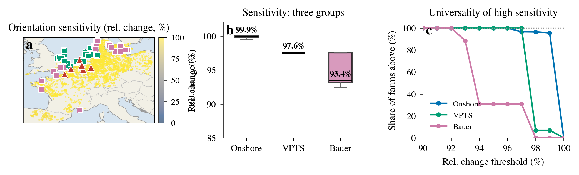
Figure S2a | Cross-source universality of directional sensitivity. (a) Kernel-density estimates of the relative change rel for the three groups (onshore, VPTS, Bauer); (b) quantile–quantile plot of onshore versus offshore rel. The three independent data sources consistently point to a 93%–100% sensitivity range, supporting the main-text conclusion that orientation sensitivity is a structural feature.
Figure S2b extends the universality test to all 171 offshore farms (the 29 VPTS, the 26 Bauer, and 116 farms entered with the remaining direction conventions), plotting each exposure curve. The three group-median curves (VPTS, Bauer, remaining) nearly coincide after normalisation, all exhibiting a sin² shape with the minimum at similar orientations. This rules out the possibility that the orientation sensitivity is driven by the particular values of any one direction dataset: the orientation achieving minimum exposure is set by the geometric structure of the migration axis, independent of the specific source of the direction data.
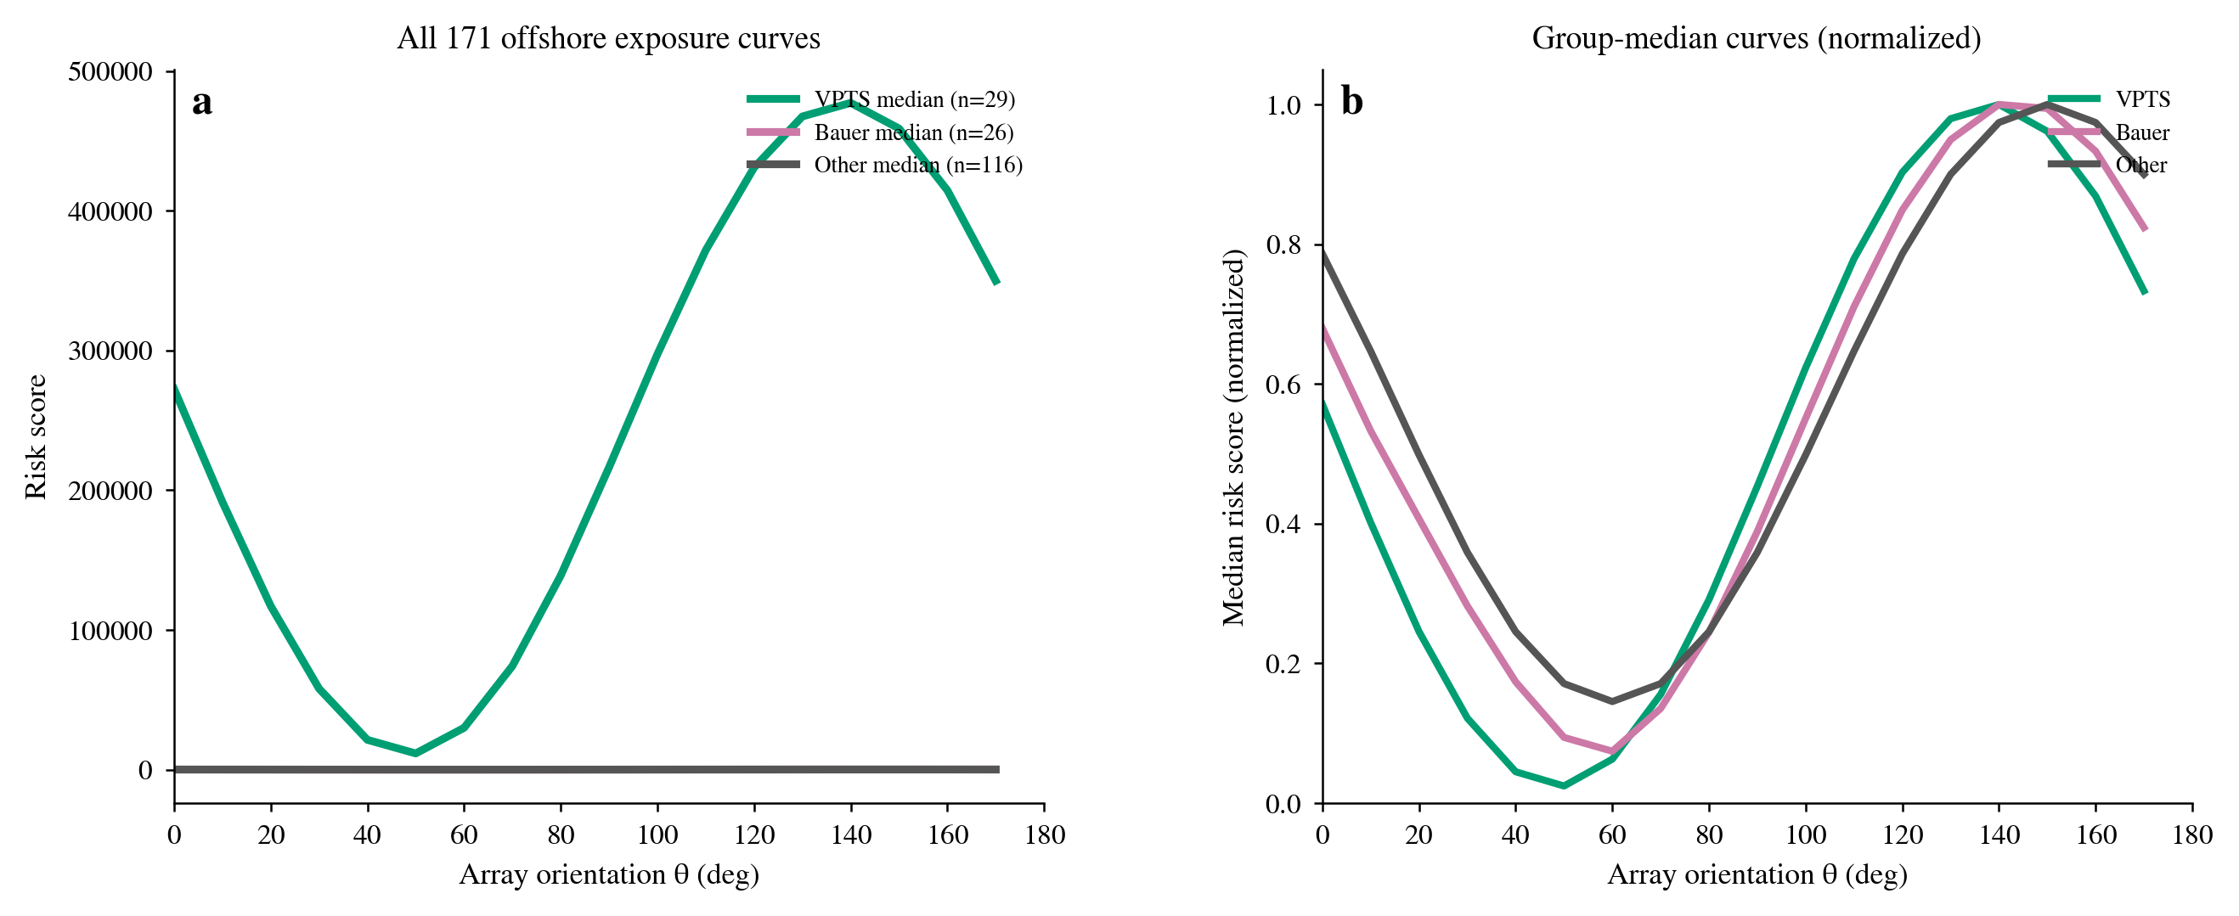
Figure S2b | Cross-source universality of directional sensitivity (full set). (a) Exposure curves of all 171 offshore farms (light grey), overlaid with the median curves of the VPTS (29), Bauer (26) and remaining (116) groups (thick lines); (b) the three group-median curves nearly coincide after normalisation, all showing a sin² shape with the minimum at similar orientations.
Supplementary Section S5 — Consolidated core metrics (R1–R4)
Table S4 consolidates the core metrics for results R1–R4 across the three groups, reported as medians unless stated otherwise (interquartile or mean in parentheses).
All three groups show very high rel (93.4%–99.9%) and avoid (90.0%–99.8%), indicating that directional sensitivity and avoidability are universal; the exposure ratio reaches 602.5× onshore (the energy-optimal orientation carries 600× the achievable minimum), versus 10.0–18.6× offshore. Δθ50 is only 14–18° and Δθ80 only 25–30°, showing that a limited rotation recovers most of the avoidable exposure; the capture fraction shows 52.9%–69.4% recoverable within 20° and 72.9%–82.2% within 30°. The strong-early-gain site share (>50% within ≤20°) is 53.8%–69.0% and (>50% within ≤30°) 69.2%–79.3%, further confirming the 'small rotation, large gain' pattern.
The reading of Table S4 is as follows. The medians of rel and avoid exceed 90% in all three groups, so 'highly orientation-sensitive and largely avoidable' is a general rule rather than a property of a few sites; the exposure ratio reaches 602.5× onshore (10.0–18.6× offshore), meaning that retaining the energy-optimal orientation leaves exposure far above the achievable minimum — the 'cost of inaction' is high; and Δθ50 of only 14–18° with 72.9%–82.2% of avoidable exposure recoverable within 30° shows that this cost can be removed with a very small rotation. The differences in absolute values between groups (e.g. the much lower offshore exposure ratio) arise because the regular layout and rotor-layer height correction of offshore farms give a different E(θ) baseline, but the relative conclusions are consistent.
Table S4 | Core metrics across the three groups (R1–R4). rel, directional sensitivity amplitude; avoid, avoidable exposure fraction; E-ratio, exposure ratio E(θ_econ)/E_min; d_full, misalignment angle; Δθ50/Δθ80, minimum rotation required to capture 50%/80% of the maximum avoidable exposure; frac, fraction of the maximum avoidable exposure recovered by rotating d° from θ_econ; RR, exposure reduction.
Metric | Onshore (n = 4,191) | Offshore VPTS (n = 29) | Offshore Bauer (n = 26)
Directional sensitivity amplitude, rel (median) | 99.9% | 97.6% | 93.4%
Site share with rel > 50% / > 80% | 100% / 100% | 100% / 100% | 100% / 100%
Avoidable exposure fraction, avoid (median; mean) | 99.8%; 97.4% | 94.6%; 90.3% | 90.0%; 77.6%
Exposure ratio, E(θ_econ)/E_min (median) | 602.5× | 18.6× | 10.0×
Misalignment angle, d_full (P25–P75) | 48° (29–60) | 40° (20–50) | 45° (30–68)
Δθ50 / Δθ80 | 17° / 29° | 14° / 25° | 18° / 30°
Capture fraction, frac (5°/10°/20°/30°) | 15.3/29.9/54.8/72.9% | 18.9/37.8/69.4/82.2% | 14.5/28.9/52.9/73.6%
Strong early gain (>50% within ≤20°/≤30°) | 58.3% / 73.9% | 69.0% / 79.3% | 53.8% / 69.2%
Strong early gain (>80% within ≤30°) | 37.6% | 58.6% | 38.5%
1% budget exposure reduction (median / mean) | 96.9% / 82.6% | 82.1% / 72.3% | 47.6% / 50.1%
1% budget AEP cost (median / mean) | 0.54% / 0.52% | 0.27% / 0.36% | 0.53% / 0.49%
1% budget capture of maximum avoidable | 98.0% | 88.1% | 74.5%
2%→5% no-additional-gain site share | 85.8% | 100% | 69.2%

Supplementary Section S6 — Energy–ecology trade-off across AEP budgets
Table S5 reports the median geometric exposure reduction across the three groups under four annual-energy-production (AEP) budgets. RR>90% is the fraction of onshore sites whose exposure reduction exceeds 90%; all reductions are relative declines in consistent units.
Exposure reduction saturates rapidly as the budget grows: onshore, a 1% budget already delivers a 96.9% median reduction, a 2% budget reaches 99.1%, and a 5% budget only rises further to 99.3%. The '2%→5% no-additional-gain' site share is as high as 85.8% (onshore), 100% (VPTS) and 69.2% (Bauer), showing that a 1–2% AEP cost is already close to the saturation point and that further budget relaxation has very small marginal gain. The energy cost remains low throughout: at a 1% budget the three-group median AEP cost is only 0.27%–0.54%.
Table S5 | Median geometric exposure reduction under four AEP budgets. RR>90%, fraction of onshore sites with exposure reduction exceeding 90%.
AEP budget | Onshore median exposure reduction | Onshore RR>90% share | VPTS median exposure reduction | Bauer median exposure reduction
0.5% | 80.0% | 40.6% | 68.8% | 37.7%
1.0% | 96.9% | 64.3% | 82.1% | 47.6%
2.0% | 99.1% | 81.8% | 84.3% | 70.6%
5.0% | 99.3% | 90.0% | 84.3% | 89.3%

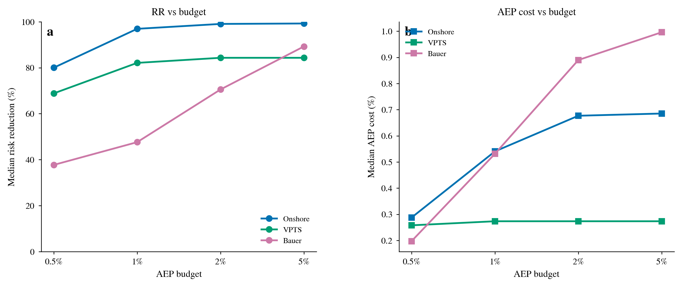
Figure S6 | Budget sensitivity. (a) Median exposure reduction RR against AEP budget (0.5%/1%/2%/5%) for the three groups; (b) median AEP cost against budget. Exposure reduction saturates rapidly as the budget grows, and the energy cost remains low throughout.
Figure S6b extends the per-farm trade-off curves offshore. Consistent with the onshore results, the offshore per-farm curves saturate rapidly as the budget grows, with most farms already close to their maximum exposure reduction within a 1% budget. The VPTS and Bauer conventions give matching curve shapes, differing only in the saturation level (VPTS generally higher), consistent with the spring direction-convention difference recorded in S7.4, but this does not affect the 'small budget reaches saturation' conclusion.
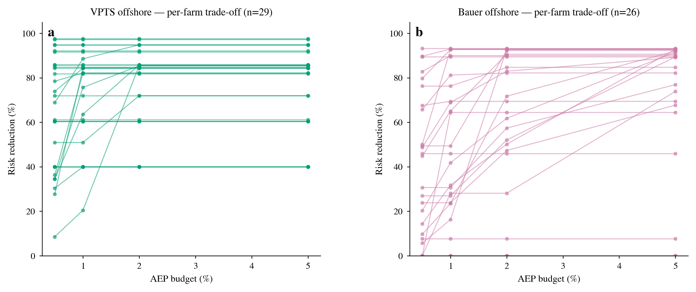
Figure S6b | Per-farm offshore energy–ecology trade-off curves (exposure reduction RR against AEP budget). (a) VPTS (radar, 29 farms); (b) Bauer (grid, 26 farms). As onshore, exposure reduction saturates rapidly as the budget grows.
Supplementary Section S7 — Robustness and sensitivity of the wake and directional assumptions
S7.0 first gives the overview table of the single-factor sensitivity analyses (Table S7a), then tests, in turn, the core assumptions of the study: the onshore wake-model parameters (S7.1–S7.2), the direction-data conventions (S7.3–S7.5), the farm construction and matching (S7.6–S7.7), the ecological premise (S7.8–S7.9), the wake-model validation (S7.10), the stratified robustness (S7.11–S7.12), the AEP orientation sensitivity (S7.13) and the sampling uncertainty (S7.14), together with the extended sensitivities for the default values, the regional stratification, the budget and the concentration weighting (S7.16–S7.19). Each analysis answers “how much does this assumption affect the core conclusion”; analyses not supported by the data are dropped by prior agreement and reported honestly.
S7.0 Single-factor sensitivity overview
Table S7a condenses the single-factor sensitivity analyses S7.1–S7.19 into one row per analysis: the assumption under test, the perturbation, the effect on the core result (median exposure reduction, 1% budget) and the conclusion. All numbers are injected from sensitivity_summary.json and bootstrap_ci.json rather than transcribed by hand.
Table S7a | Single-factor sensitivity overview (S7.0). RR is the median exposure reduction (1% AEP budget).
Subsection | Assumption under test | Perturbation | Effect on median RR (1%) | Conclusion
S7.1 | Wake orientation penalty underestimated | Amplify 1.5×/2×/3× | 96.9% → 90.1%/80.0%/58.9% | still ≈60% at 3×, robust
S7.2 | Decay constant α | 0.075 → 0.05 | 96.9% → 95.0% (2.0 pp) | second-order effect
S7.3 | ERA5 wind direction as substitute | vs measured direction | mean error 77–102°, 14–50% within 30° | not substitutable, rejected
S7.4 | Offshore direction convention | VPTS vs Bauer | spring 70.2°, autumn 3.0° | spring convention gap explains difference
S7.5 | Seasonal weighting | concentration vs equal | median difference 0.00 pp | negligible
S7.6 | DBSCAN parameters | eps 2–5 km × ms 2–5 | farm count 8,902 → 3,221 | continuous and predictable
S7.7 | Bauer match radius | 50–300 km | RR 97.4%–96.9% | plateau from ≥150 km
S7.8 | Flight height (rotor-layer fraction) | 0–71% per station (26–35% pooled) | relative change invariant | robust
S7.9 | Migration phenology | seasonal definition | axis direction unchanged | robust
S7.10 | Wake-model structure | Jensen vs FLORIS | AEP sensitivity 2.7% vs 8.8% | both far below exposure
S7.11 | Farm size | 5 size bins | RR > 96% in all bins | size-independent
S7.12 | PCA principal axis | explained-variance ratio | median 0.910 | axis reliable
S7.13 | AEP orientation sensitivity | onshore vs offshore | 2.74% vs 8.82% | both far below exposure
S7.14 | Sampling uncertainty | bootstrap 10,000× | onshore RR CI [96.6, 97.3]%; offshore small-sample wider | onshore precise, offshore wide
S7.16 | Defaults (rotor/hub/capacity) | one-dimensional default sweep | rotor |Δ|≤0.03, hub ≤0.01, capacity ≤0.12 pp | only capacity default perceptible
S7.17 | Geographic region stratification | recompute RR by region | 45.6–98.0% | Iberia weaker, rest robust
S7.18 | AEP budget | 0.1%–20% extended sweep | RR 0.0%→99.3% | monotone saturation
S7.19 | Concentration weight λ | 0–1 continuous sweep | median RR 97.0–97.9% | nearly insensitive

S7.1 Wake-model orientation-penalty sensitivity
The orientation-penalty term of the baseline Jensen model quantifies the AEP loss from increased wake overlap as the array turns away from the dominant wind direction. To test whether this penalty is underestimated (which would overstate the energy cost of rotating the array and hence exaggerate the favourability of the trade-off), we amplify it by 1.5×, 2× and 3×. Result: the median exposure reduction (1% budget) falls from 96.9% (baseline) to 90.1%, 80.0% and 58.9%, respectively. Even under the most extreme 3× penalty, the median exposure reduction remains near 60%. The uncertainty band around the core figure is roughly 59%–97%. The core conclusion — a large exposure reduction at very small energy cost — is robust within the uncertainty range of the wake penalty.
Table S6 | Wake orientation-penalty amplification sensitivity (per-farm violins in Figure S7.1a).
Penalty amplification factor | 1.0× (baseline) | 1.5× | 2.0× | 3.0×
Median exposure reduction (1% budget) | 96.9% | 90.1% | 80.0% | 58.9%

S7.2 Decay-constant sensitivity
The onshore wake-decay constant α controls the rate of wake recovery. Lowering α from the baseline 0.075 to 0.05 (slower wake recovery, stronger wake effect) reduces the median exposure reduction only from 96.9% to 95.0% (a drop of 2.0 percentage points), a second-order effect. Neither the amplification term (S7.1) nor α (S7.2) explains the residual gap between the onshore (≈2.7%) and offshore FLORIS (≈8.8%) AEP orientation sensitivities, which more likely stems from the model structure and the directional data conventions (S7.4).
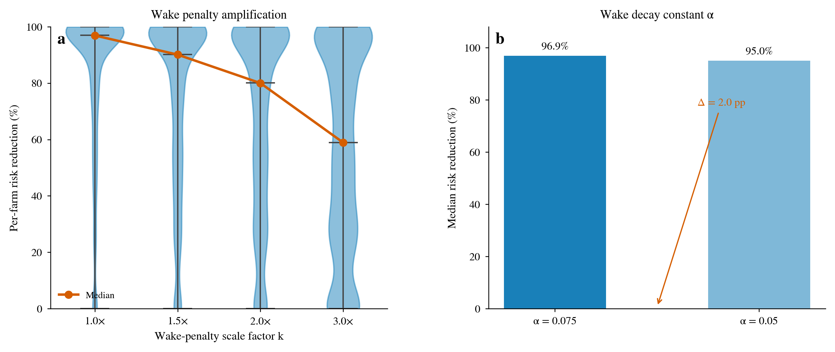
Figure S7.1 | Wake-penalty amplification and decay-constant sensitivity. (a) Per-farm exposure-reduction RR distributions (violins) and medians (red line) under wake orientation-penalty amplification k = 1.0/1.5/2.0/3.0; (b) median exposure reduction for decay constants α = 0.075 and 0.05.
Figure S7.2b confirms this at the curve level: changing the decay constant α barely changes the AEP(θ) shape or optimal orientation of a representative farm, with the two normalised curves nearly overlapping; by contrast the exposure E(θ) of the same farm varies far more across orientations. This explains mechanistically why the core conclusion is insensitive to the choice of α.
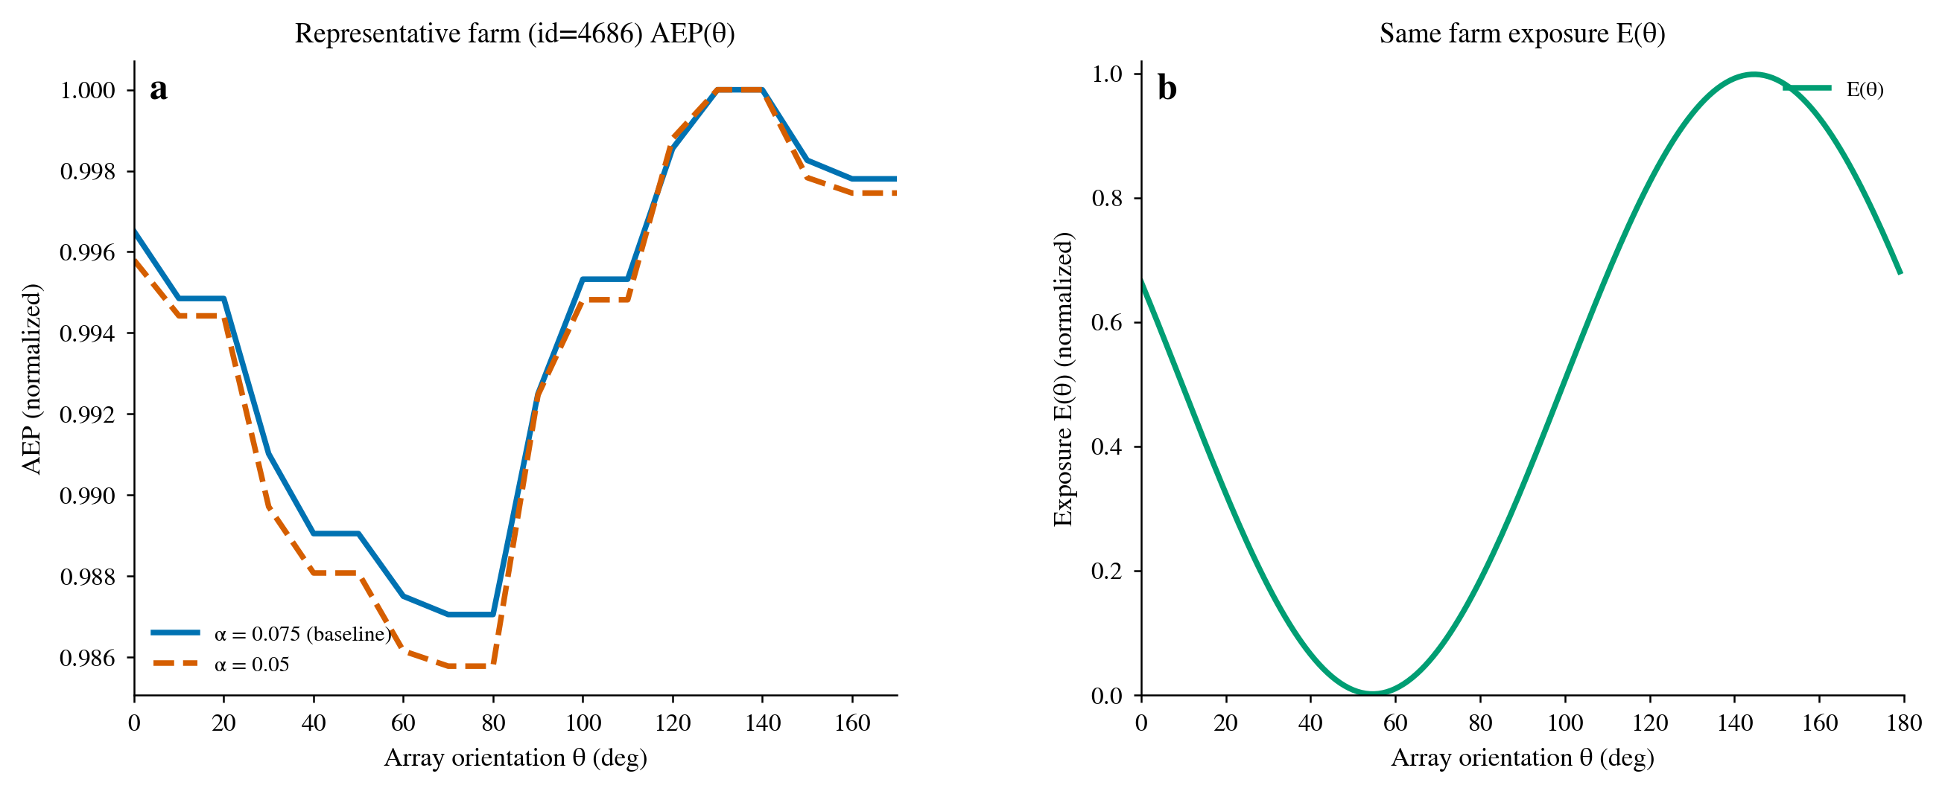
Figure S7.2b | Effect of the decay constant α on the AEP(θ) curve (representative onshore farm). (a) Normalised AEP(θ) curves for α = 0.075 (baseline) and α = 0.05 nearly coincide; (b) the exposure E(θ) curve of the same farm, whose cross-orientation variation is far larger than that of AEP.
S7.3 Irreplaceability of ERA5 meteorological wind direction
Migratory-bird direction cannot be replaced by meteorological wind direction. Comparing the ERA5 meteorological wind direction against the measured bird direction, the mean circular-angle differences under the four conventions are: VPTS spring 77°, VPTS autumn 102°, Bauer spring 101°, Bauer autumn 79°; the fractions within 30° are respectively only 14%, 24%, 35% and 50%. Meteorological wind direction reflects the prevailing air flow, whereas the migration direction of birds (especially nocturnally migrating songbirds and thrushes) is set by navigation mechanisms rather than the local wind field, the two being nearly orthogonal or anti-parallel at most stations. ERA5 therefore cannot substitute for bird observations as the ecological direction input. The Bauer directions used in this study are the grid-product directions, not ERA5-shifted values.
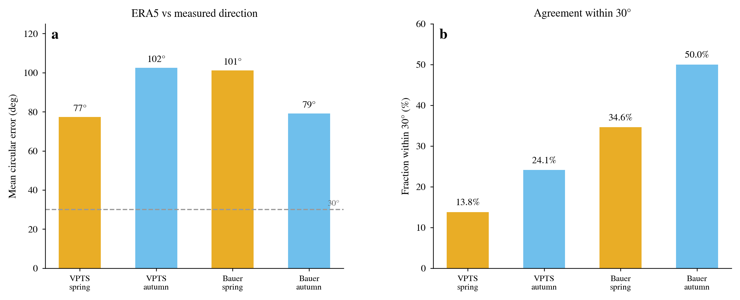
Figure S7.3 | Comparison of ERA5 meteorological wind direction against measured bird direction. (a) Mean circular-angle difference under the four conventions (dashed line = 30° threshold); (b) fraction within 30°. ERA5 agrees poorly with the measured direction and cannot substitute for bird observations.
Figure S7.3b explains at the per-farm level why ERA5 is irreplaceable: the scatter points lie neither on the identity line (Δ = 0°) nor on a uniform 180° shift (dotted line), showing that the deviation between meteorological wind direction and bird direction is not a simple systematic offset but a complex relationship varying by station and season; the circular-angle-difference distribution shows that the vast majority of farm–season pairs exceed the 30° threshold. Any attempt to substitute ERA5 wind direction for bird direction would therefore introduce uncontrollable directional error.
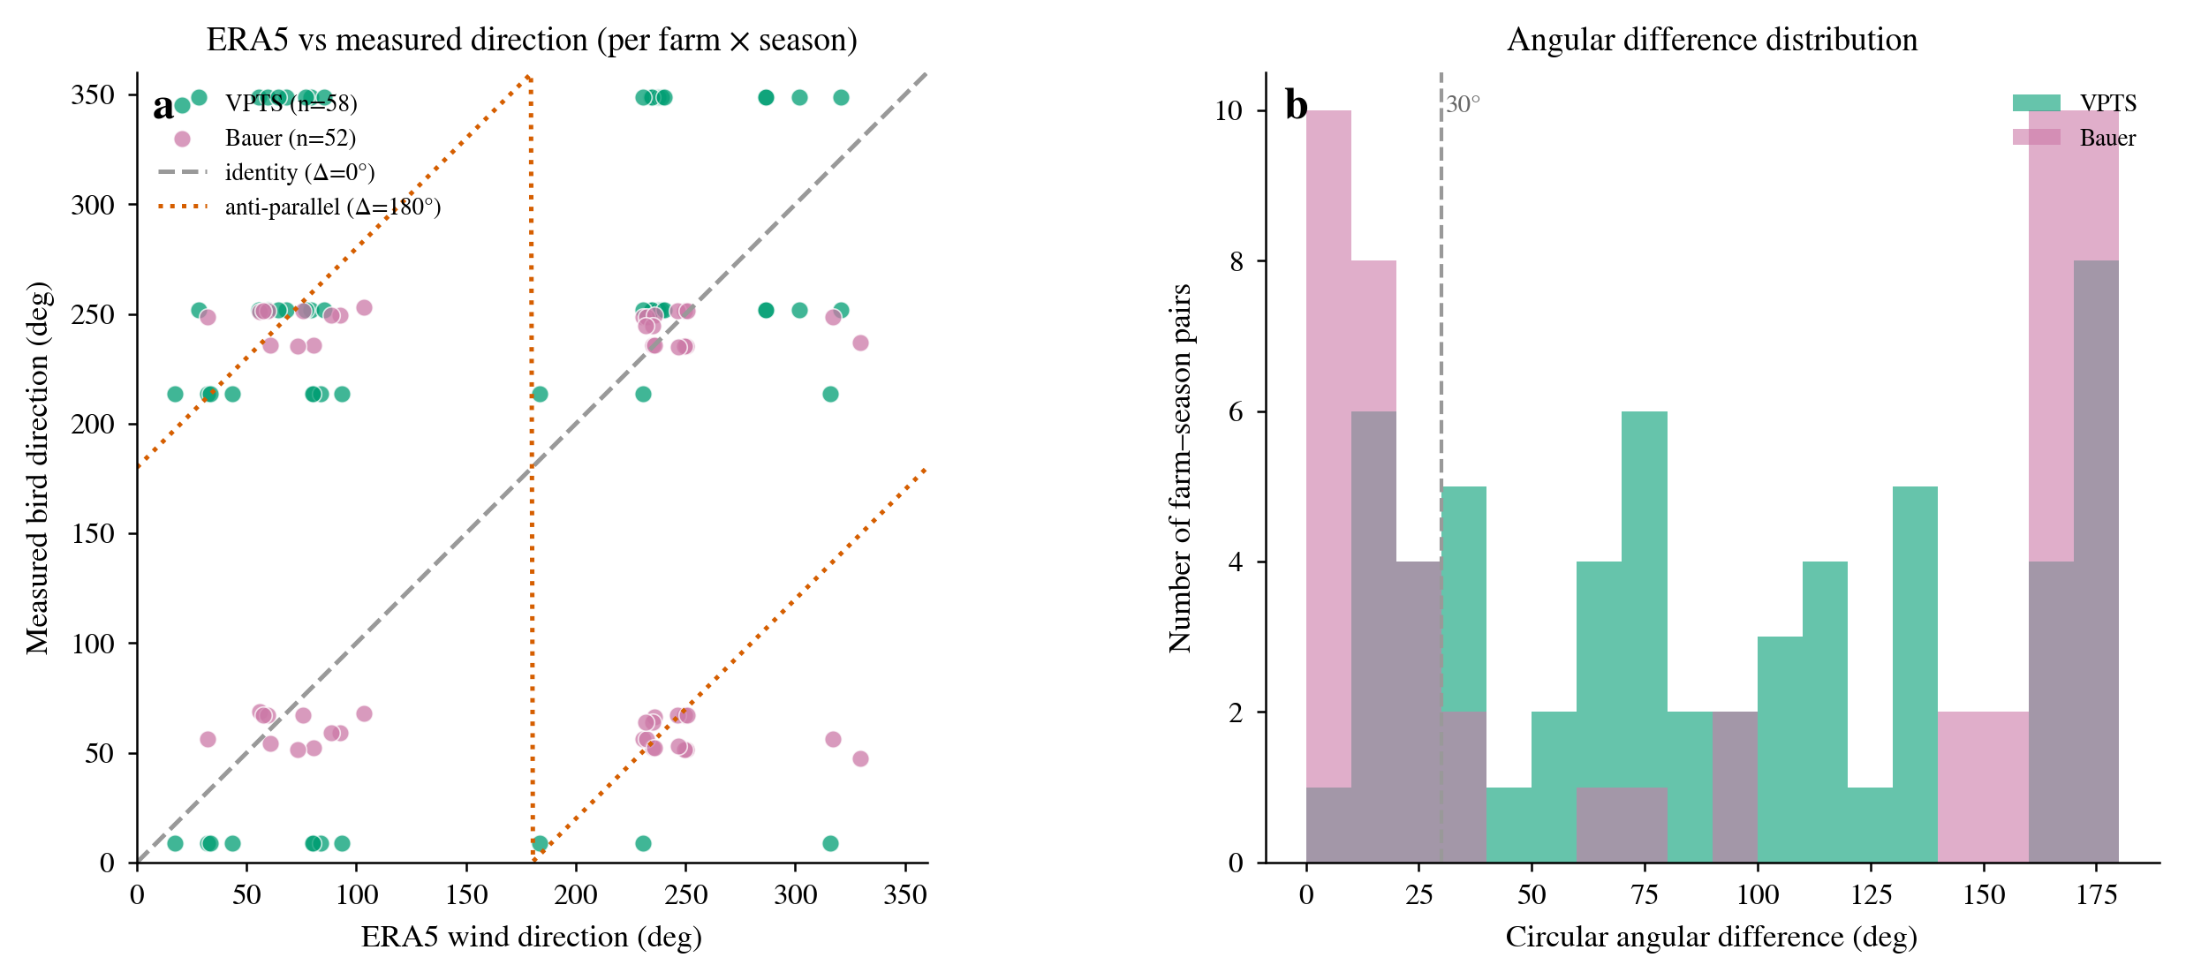
Figure S7.3b | Per-farm scatter of ERA5 wind direction against measured bird direction (each farm × each season). (a) ERA5 wind direction vs measured bird direction, with identity (Δ = 0°, dashed) and anti-parallel (Δ = 180°, dotted) reference lines; (b) circular-angle-difference distribution, most farm–season pairs far exceeding the 30° threshold (dashed).
S7.4 Offshore directional-convention difference (VPTS vs Bauer)
Offshore bird direction has two independent conventions: VPTS weather radar (direct rotor-layer observation) and the Bauer migration grid (model product). In spring their median directions differ by 70.2° (VPTS 348.9° vs Bauer 59.1°), whereas in autumn they differ by only 3.0° (VPTS 251.8° vs Bauer 248.8°). The large spring convention difference explains the difference in exposure reduction between VPTS and Bauer. We adopt Bauer as the primary convention (consistent with onshore and with broader coverage) and VPTS as an upper-bound reference from direct radar observation; the two conventions agree closely in autumn, corroborating the robustness of the directional structure.
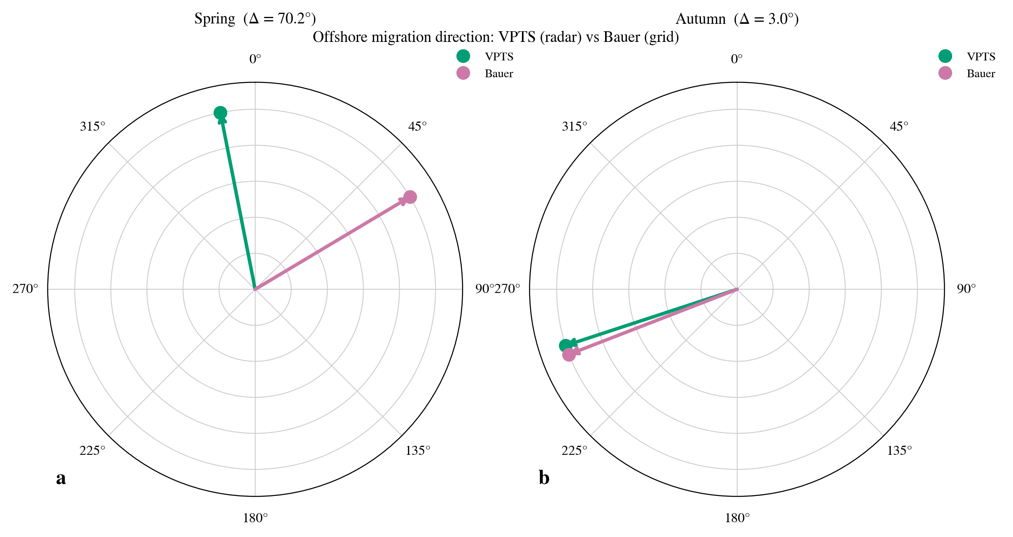
Figure S7.4 | Offshore bird-direction convention: median directions of VPTS (radar) and Bauer (grid) as polar arrows, differing by 70.2° in spring and only 3.0° in autumn.
S7.5 Seasonal weighting: concentration vs equal
Onshore, the two seasons are weighted by directional concentration (S1.1). To test the effect of this weighting, we compare the per-farm exposure-reduction difference between concentration weighting and equal weighting: the median difference is 0.00 percentage points and the mean difference 0.05 percentage points (n = 4,191). Concentration weighting has almost no effect on the core results; the direction-input convention is robust.
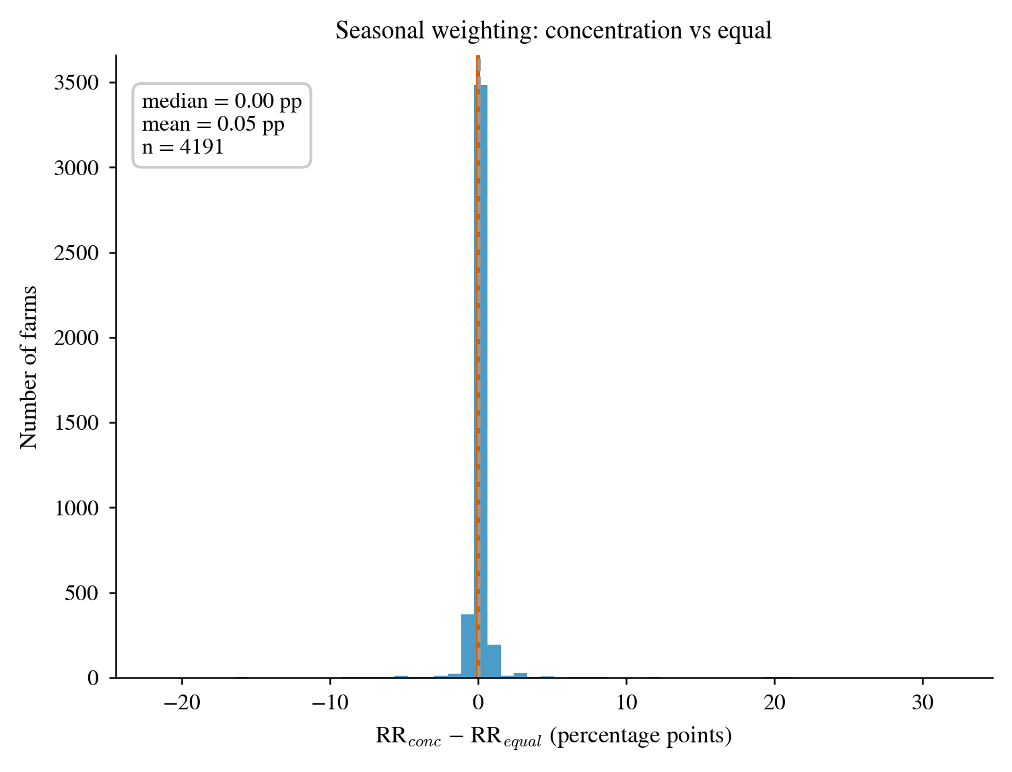
Figure S7.5 | Seasonal-weighting sensitivity: distribution of the per-farm exposure-reduction difference (percentage points) between concentration weighting and equal weighting. The distribution is concentrated near 0, showing that the weighting has almost no effect.
S7.6 DBSCAN clustering-parameter sweep
Farm clustering is sensitive to the clustering parameters. Sweeping eps ∈ {2,3,4,5} km × min_samples ∈ {2,3,4,5}, the farm count declines monotonically from 8,902 (eps = 2 km, min_samples = 2) to 3,221 (eps = 5 km, min_samples = 5). We adopt eps = 3 km, min_samples = 2, giving 7,238 clusters (5,954 farms after PCA). The effect of varying the clustering parameters within a reasonable range on the farm count is continuous and predictable; the PCA principal axis (S7.12) is robust to disagreements in farm definition. Table S7 gives the full sweep.
Table S7 | Full sweep of DBSCAN farm counts over eps and min_samples. We adopt eps = 3 km, min_samples = 2 (7,238 clusters, 5,954 farms after PCA).
eps (km) | min_samples | Farm clusters | Turbines in clusters | Fraction in clusters
2 | 2 | 8,902 | 95,849 | 0.9554
2 | 3 | 7,104 | 92,253 | 0.9195
2 | 4 | 5,769 | 87,807 | 0.8752
2 | 5 | 4,849 | 83,489 | 0.8322
3 | 2 | 7,238 | 97,179 | 0.9686
3 | 3 | 5,954 | 94,611 | 0.9430
3 | 4 | 5,016 | 91,581 | 0.9128
3 | 5 | 4,348 | 88,519 | 0.8823
4 | 2 | 5,917 | 98,014 | 0.9769
4 | 3 | 4,976 | 96,132 | 0.9582
4 | 4 | 4,271 | 93,885 | 0.9358
4 | 5 | 3,724 | 91,448 | 0.9115
5 | 2 | 4,850 | 98,575 | 0.9825
5 | 3 | 4,124 | 97,123 | 0.9681
5 | 4 | 3,613 | 95,440 | 0.9513
5 | 5 | 3,221 | 93,599 | 0.9329

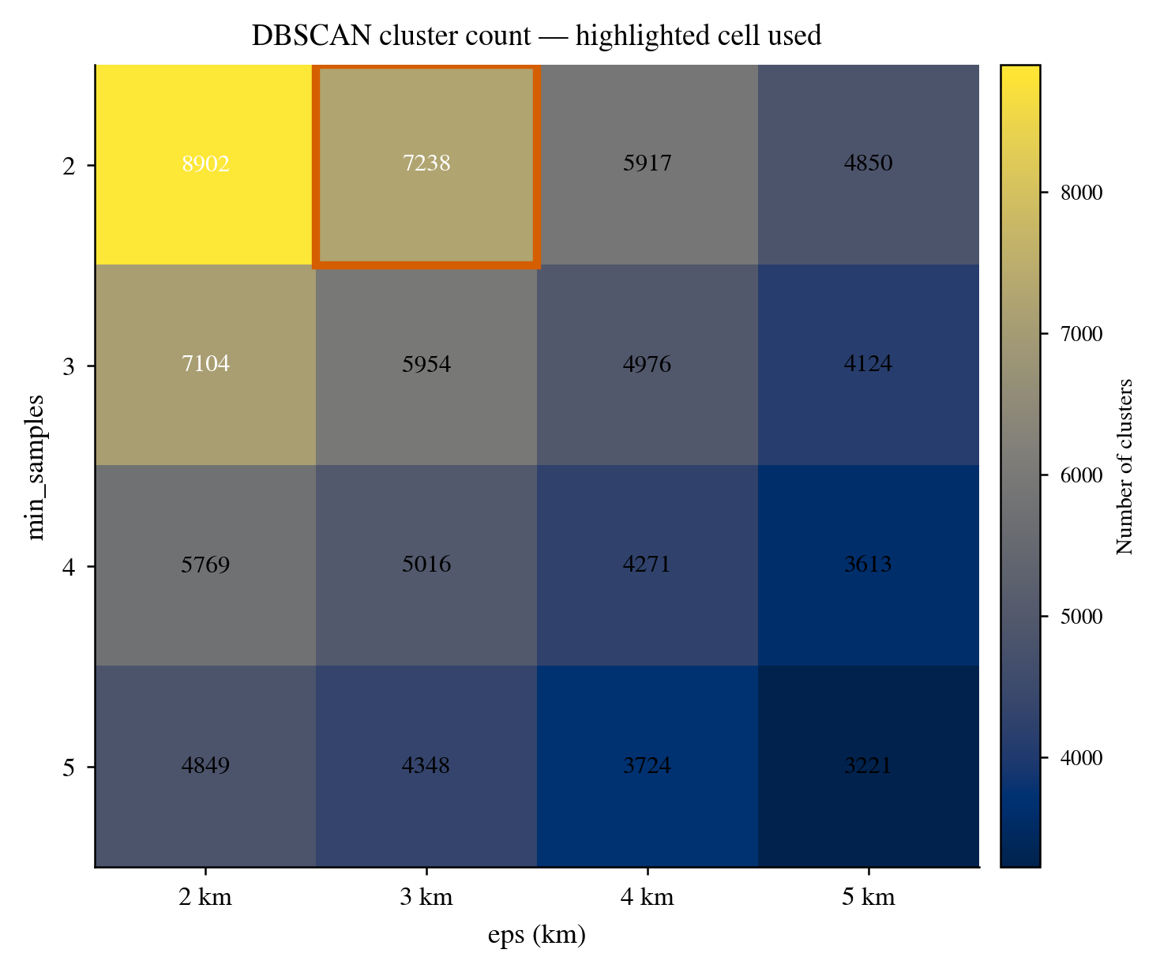
Figure S7.6 | Sweep of DBSCAN farm counts over eps and min_samples (heatmap). The red box highlights the adopted eps = 3 km, min_samples = 2 (7,238 clusters, 5,954 farms after PCA).
S7.7 Bauer match-radius sweep
The Bauer match radius determines how many onshore farms enter the trade-off analysis. As the radius grows from 50 km to 300 km, the number of included farms rises from 3,368 to 4,586, and the median exposure reduction (1% budget) varies between 97.4% and 96.9%; we adopt 200 km (4,191 farms, 96.9%). The match-radius choice does not change the core conclusion, and at 200 km the exposure reduction has already entered a plateau (over the 150–300 km range the RR moves by only 0.2 percentage points).
Table S8 | Bauer match-radius sweep (200 km adopted).
Radius (km) | Matched farms | Farms with AEP | Median exposure reduction (1%)
50 | 3,382 | 3,368 | 97.4%
100 | 3,608 | 3,591 | 97.3%
150 | 3,927 | 3,906 | 97.1%
200 | 4,221 | 4,191 | 96.9%
300 | 4,625 | 4,586 | 96.9%

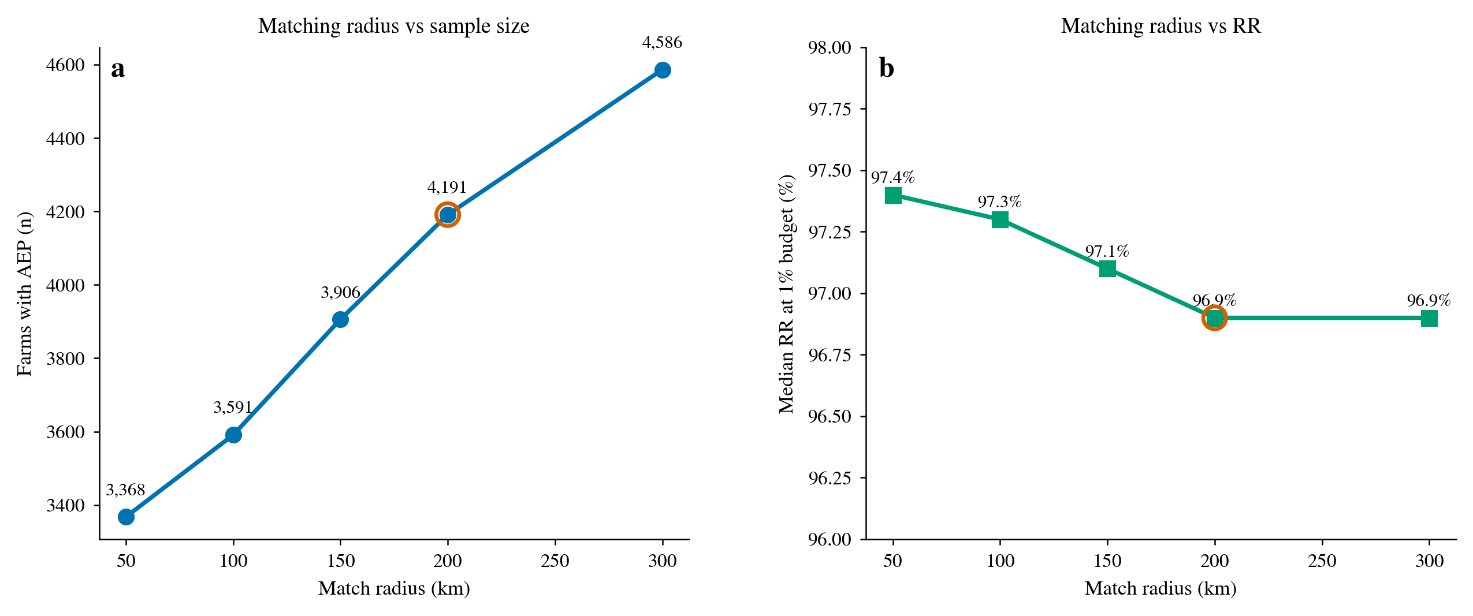
Figure S7.7 | Bauer match-radius sensitivity. (a) Number of included farms against radius; (b) median exposure reduction against radius. The red circle marks the adopted 200 km.
S7.8 Flight height (rotor-layer fraction)
The flight-height distribution (Figure S1d, Figure S7.8a) shows that the 0–200 m rotor layer accounts for about 26% of the nocturnal-migration total-height flux in spring and about 35% in autumn in the pooled convention; the per-station values differ substantially (0–71%), with station nlhrw highest (63–71%), bejab next (36–53%), and the rotor-layer flux at deess and frabb almost zero (Figure S7.8b). This height overlap is the ecological premise of the geometric-exposure analysis, and it is stable across stations rather than dependent on any individual station. If future machines had hub heights markedly above 200 m the overlap fraction could change and would need re-assessment; current mainstream machines (hub height 90–160 m), however, all fall within the main bird flight-height band.
The rotor-layer fraction is strongly dispersed across stations (Figure S7.8b, cross-station × season median 21%), reflecting differences in the bird assemblages and flight behaviour at different stations: nocturnally migrating songbirds and thrushes generally fly low, while high-altitude migrants (e.g. certain waders) mostly fly above the rotor layer. This dispersion does not weaken the conclusion, because the core inference depends on the relative change of exposure with orientation rather than the absolute exposure level — as long as any non-zero fraction of birds enters the rotor layer, the sin² geometry's response to orientation holds, and this relative change is independent of the specific value of the rotor-layer fraction.

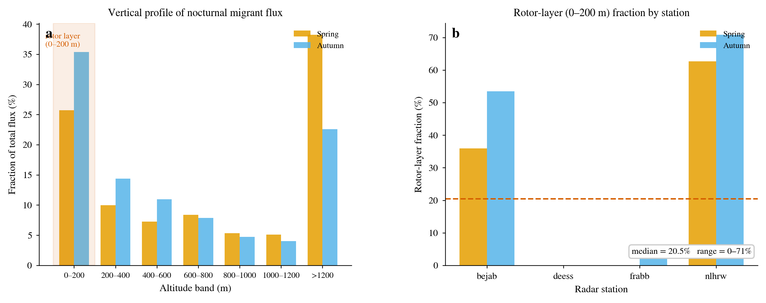
Figure S7.8 | Flight-height distribution (supplementary). (a) Fraction of nocturnal-migration flux by 200-m height band (spring/autumn, 0–200 m rotor layer highlighted); (b) per-station 0–200 m rotor-layer fraction (spring/autumn, dashed line = cross-station × season median).
S7.9 Migration phenology
Migration flux is concentrated in spring (March–May) and autumn (August–November) (Figure S1f), consistent with the seasonal definition used in this study. Small changes in the seasonal definition do not change the migration axis direction and therefore do not change the orientation-sensitivity conclusion.
Phenology has a further implication for the operability of the trade-off: the benefit of exposure reduction only needs to take effect during the migration season, whereas array orientation is a static decision made at construction time, so there is no 'turn during the migration season' operational cost. Orientation optimisation is thus a one-off, zero-running-cost abatement lever, which, combined with the strong temporal concentration of migration, further strengthens its cost effectiveness.

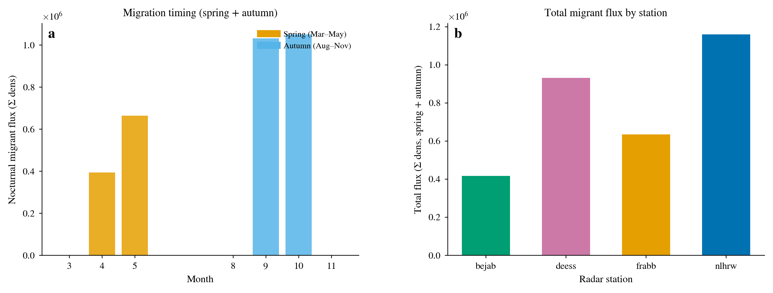
Figure S7.9 | Migration phenology (supplementary). (a) Monthly distribution of nocturnal-migration flux (bimodal: spring March–May, autumn August–November); (b) total flux per station (spring + autumn combined).
S7.10 Wake-model validation (AEP orientation polar)
The onshore AEP(θ) curves are generated by the Jensen model (Figure S3c). The AEP cross-orientation variation (mean 2.7%) is far smaller than the exposure cross-orientation variation (median rel 99.9%), a difference of more than two orders of magnitude. This is precisely the physical basis of 'large exposure reduction at very small energy cost': farm orientation is set mainly by the wind rose, whereas bird exposure is set mainly by the migration axis, and the two are almost decoupled.

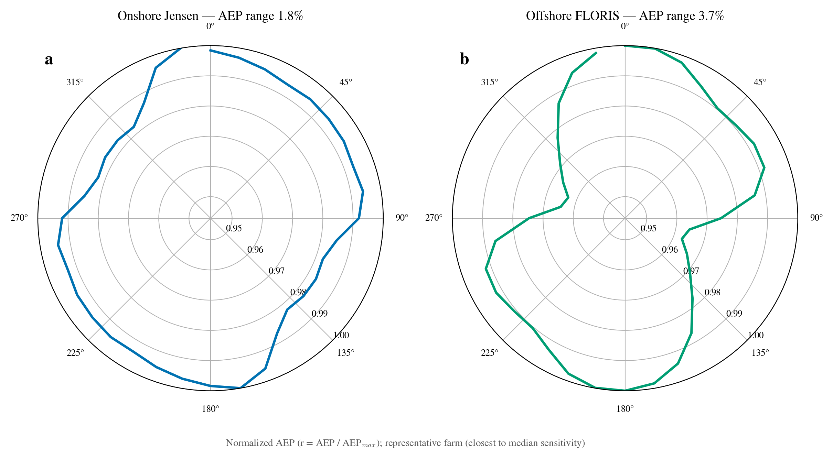
Figure S7.10 | Wake-model AEP(θ) polar (supplementary). Selecting the representative farm closest to the median sensitivity, the normalised AEP as a function of array orientation (polar, r = AEP/AEP_max). (a) Onshore Jensen; (b) offshore FLORIS. The cross-orientation variation of both is far smaller than that of exposure.
S7.11 Onshore farm-size stratification
Stratifying the onshore farms into five turbine-count bins, the median exposure reduction of each bin is: <5 turbines 96.5% (n = 1,121), 5–9 96.2% (n = 1,460), 10–19 97.5% (n = 897), 20–49 98.5% (n = 536), ≥50 96.9% (n = 177). Orientation sensitivity exceeds 96% in every size bin and does not depend on farm size. Country stratification is unavailable because the OSM country field is 76% missing and its non-empty values are manufacturer fragments rather than ISO codes, so it is dropped by prior agreement, retaining only the size stratification.
Table S9 | Onshore farm-size stratification (by turbine count).
Size bin | Farms | Median exposure reduction | Mean exposure reduction
<5 | 1,121 | 96.5% | 82.4%
5-9 | 1,460 | 96.2% | 81.4%
10-19 | 897 | 97.5% | 84.0%
20-49 | 536 | 98.5% | 84.4%
>=50 | 177 | 96.9% | 79.8%

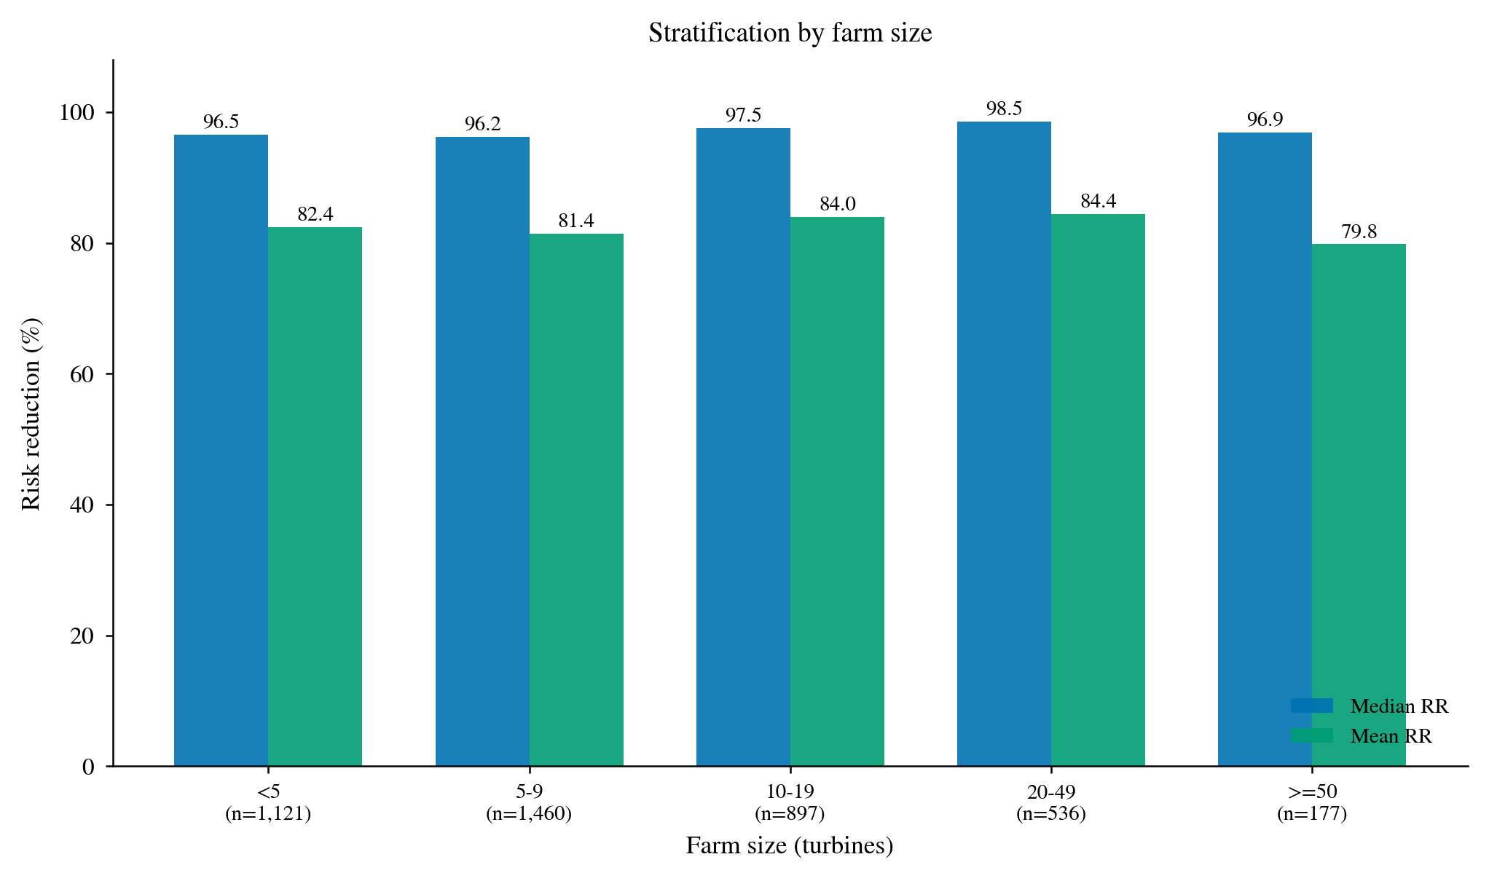
Figure S7.11 | Median/mean exposure reduction by onshore farm-size bin. Exposure reduction exceeds 96% in all five bins.
S7.12 PCA explained-variance-ratio distribution
The explained-variance ratio of the onshore farm principal-axis PCA has mean 0.877 and median 0.910 (P25–P75 0.804–0.977, n = 5,954). The vast majority of farms are well described by a single dominant orientation, so the PCA principal-axis extraction is reliable; the few farms with low explained variance (elongated or L-shaped layouts) carry higher axis uncertainty, but they are limited in number and do not affect the overall conclusion.
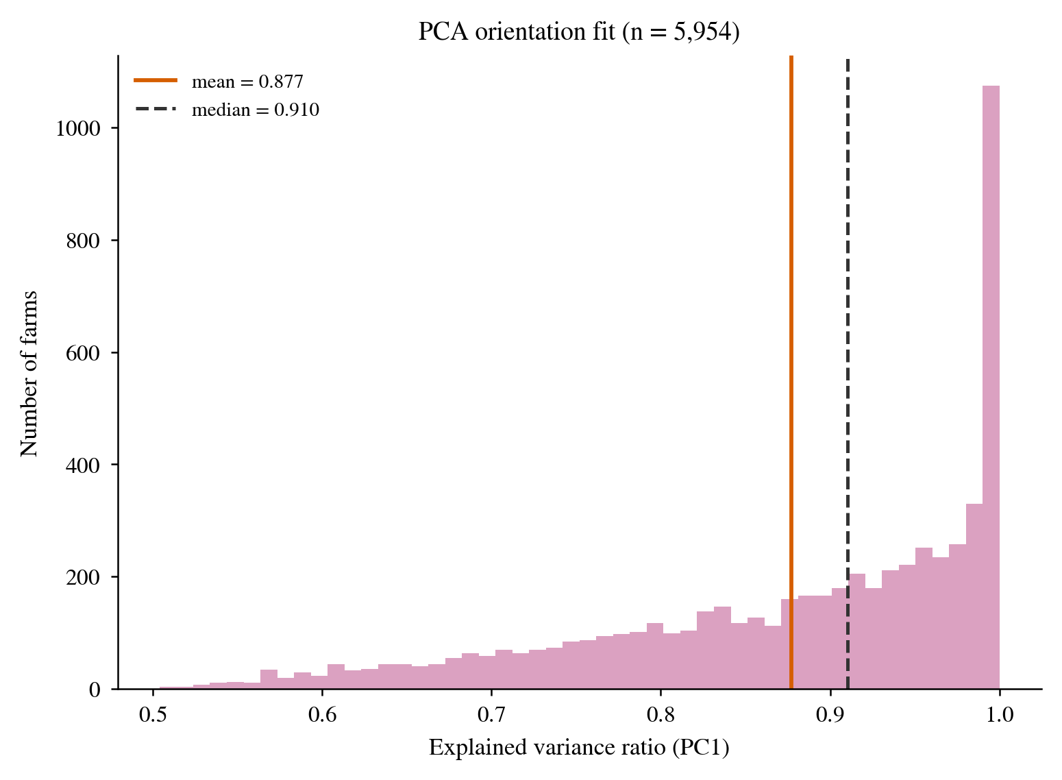
Figure S7.12 | Distribution of the onshore farm PCA principal-axis explained-variance ratio (PC1). Mean 0.877, median 0.910.
S7.13 Onshore vs offshore AEP orientation sensitivity
AEP cross-orientation sensitivity: onshore mean 2.74% (median 1.76%), offshore mean 8.82% (median 3.71%). The offshore FLORIS orientation sensitivity is about three times the onshore Jensen value, possibly because the regular layout and tighter spacing of offshore farms make orientation affect wake losses more strongly. Both, however, are far smaller than the exposure orientation sensitivity, further showing that the favourability of the energy–ecology trade-off holds under both model systems.
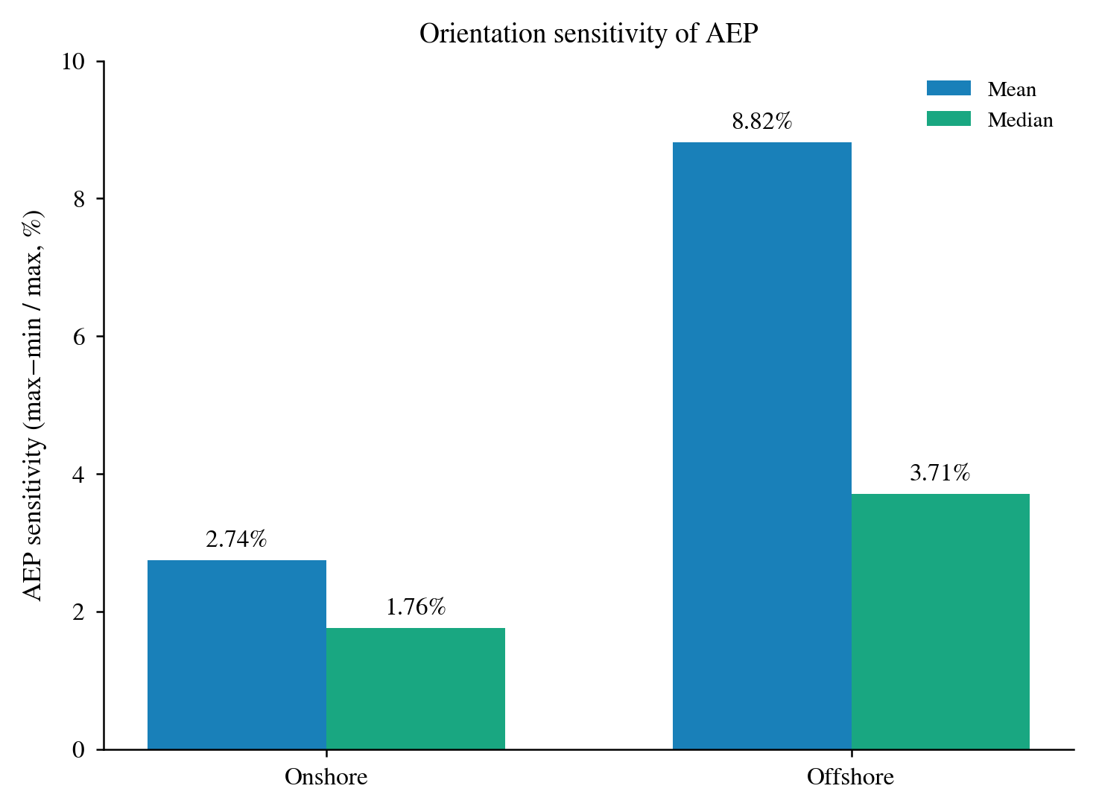
Figure S7.13 | Onshore and offshore AEP cross-orientation sensitivity (max−min relative change, mean/median).
S7.14 Bootstrap confidence intervals for the sampling uncertainty of the core metrics
The core trade-off metrics (median exposure reduction and AEP cost at a 1% budget) come from finite samples (onshore 4,191 farms, offshore VPTS 29 farms, Bauer 26 farms). To quantify the sampling uncertainty, we resample each group's per-farm results 10,000 times with replacement and report the 2.5–97.5 percentile interval of the median and the mean (Table S7b). Because the onshore sample is very large, the 95% interval of its median exposure reduction is extremely narrow (96.6%–97.3%), i.e. precisely estimated; the two offshore groups have small samples and markedly wider intervals (VPTS 61.1%–84.8%, Bauer 27.5%–72.6%), so the offshore absolute reduction values should be read as directional evidence rather than precise estimates. Even at the lower interval bounds, however, the exposure reduction is still large and positive and the AEP cost still below 1%, so the qualitative conclusion — a large exposure reduction at very small energy cost — does not depend on sampling variation.
Table S7b | Bootstrap 95% confidence intervals for the core trade-off metrics at a 1% budget (10,000 resamples, percentile method). RR is the exposure reduction (%); AEP cost is the actual loss as a fraction of AEP_max (%).
Group | n | RR median (95% CI) | RR mean (95% CI) | AEP cost median (95% CI)
Onshore | 4,191 | 96.9% [96.6, 97.3] | 82.6% [81.7, 83.4] | 0.54% [0.52, 0.56]
VPTS | 29 | 82.1% [61.1, 84.8] | 72.3% [64.6, 79.5] | 0.27% [0.19, 0.38]
Bauer | 26 | 47.6% [27.5, 72.6] | 50.1% [37.6, 62.1] | 0.53% [0.28, 0.75]

S7.15 Spring/autumn single-season decomposition (spring-only / autumn-only)
The main text merges the spring and autumn seasons by 'directional-concentration weighting' (S7.5 has shown that the concentration-versus-equal difference is negligible). Here we test further: if exposure is computed from the spring-only or autumn-only seasonal direction, does the core conclusion change? For the 4,191 onshore farms, we recompute E(θ) with the single-season direction at a 1% AEP budget and run onshore_tradeoff to obtain the single-season RR (θ_econ is set by the wind resource alone and is shared by the three conventions).
The result is: median RR 97.77% spring, 97.88% autumn, and 96.94% for the main-text convention (concentration weighting); the per-farm difference between the spring-only and autumn-only RR has median 0.00 pp and mean 1.09 pp; the median angular separation of the spring and autumn migration axes under the 180° periodicity is 3.0°.
The three conventions are almost indistinguishable, because the spring and autumn migration axes are nearly anti-parallel and the sin² exposure geometry cannot tell the two seasons apart under 180° periodicity; the core conclusion of 'a large exposure reduction at very small energy cost' is therefore unchanged whether one uses a single-season or the weighted convention. This result complements S7.5 (seasonal weighting), the two together ruling out the two convention perturbations of 'how the two seasons are merged' and 'whether a single season suffices'.

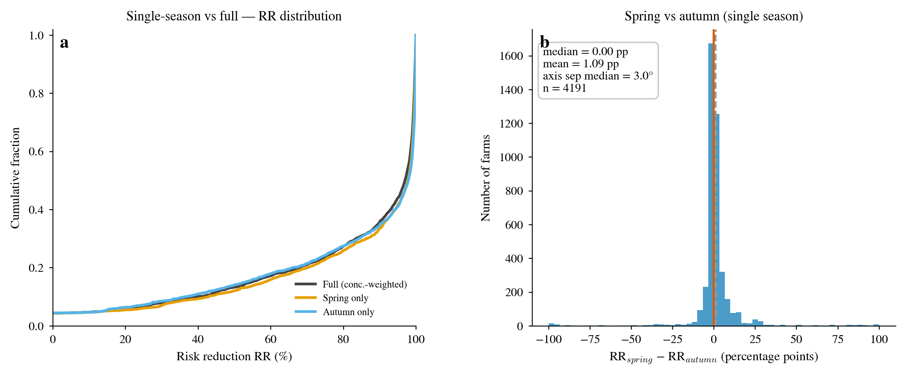
Figure S7.15 | Spring/autumn single-season decomposition sensitivity. (a) Cumulative distribution of RR for the three conventions (concentration-weighted full, spring-only, autumn-only), the three curves nearly coinciding; (b) distribution of the per-farm difference between the spring-only and autumn-only RR (pp), concentrated at 0 (median 0 pp).
S7.16 Default-value sweep (rotor diameter / hub height / capacity)
The per-turbine attribute missing rate onshore is high (S2.2); missing values are first filled by the spatially nearest entry in the Bauer database, and only when both are missing does the value fall back to the default (rotor diameter 70 m, hub height 70 m, capacity 2 MW). To test the effect of the defaults on the core result, we sweep each of the three defaults in one dimension: rotor diameter 60/70/90/110 m, hub height 60/70/90/110 m, capacity 1500/2000/2500/3000 kW; at each point we recompute the Jensen AEP(θ) curve and run the trade-off pipeline, comparing the median exposure reduction RR at a 1% budget against the baseline (70 m/70 m/2 MW).
The baseline median RR is 96.94% (n = 4,191). In the rotor-diameter sweep the maximum deviation of the median RR is 0.03 percentage points (37 farms on default), and for hub height 0.01 percentage points (34 farms), both near zero as expected — only very few farms fall on the default. The capacity sweep has a maximum deviation of 0.12 percentage points (1,018 farms on default, 24.3% of the trade-off subset), the only perceptible one of the three but still far smaller than the exposure reduction itself (96.9%).
Table S7c | Default-value sweep (S7.16). RR is the median exposure reduction (1% AEP budget); baseline 70 m/70 m/2 MW.
Default parameter | Swept values | Median RR range (1%) | Max |Δ| (pp) | Farms on default
Rotor diameter (m) | 60/70/90/110 | 96.91–96.94% | 0.03 | 37
Hub height (m) | 60/70/90/110 | 96.93–96.94% | 0.01 | 34
Capacity (kW) | 1500/2000/2500/3000 | 96.82–96.99% | 0.12 | 1018

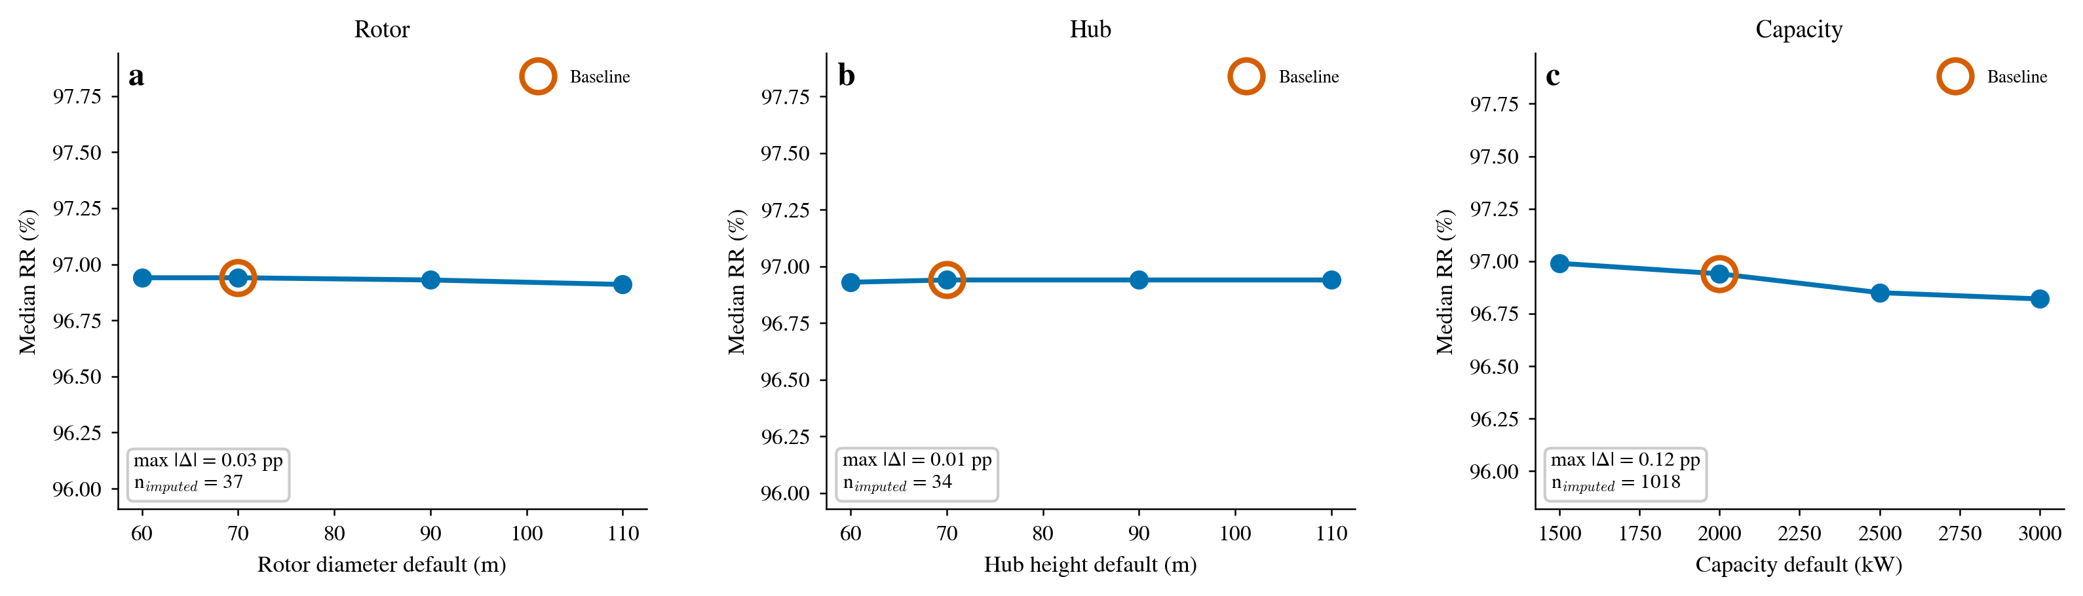
Figure S7.16 | Default-value sweep (rotor diameter / hub height / capacity). (a)–(c) Median RR (1% budget) under each default, open circle = baseline; rotor/hub-height nearly flat, capacity weakly responsive.
S7.17 Geographic regional stratification
Country stratification is unavailable because the OSM country field is 76% missing and its non-empty values are manufacturer fragments rather than ISO country codes (S7.11). We therefore use geographic latitude/longitude boxes to split the onshore farms into five regions — UK, Central Europe, Nordic, Iberia and France (the rest assigned to Other) — and compute the median exposure reduction RR in each at a 1% budget.
Table S7d | Regional stratification (S7.17). RR is the median exposure reduction (1% AEP budget).
Region | Farms | Median RR (%) | Mean RR (%)
UK | 52 | 88.55 | 81.66
Central Europe | 2,742 | 97.77 | 85.81
Nordic | 462 | 96.80 | 79.91
Iberia | 207 | 45.62 | 48.10
France | 210 | 86.78 | 74.40
Other | 518 | 98.00 | 84.96

The regional median RR ranges from 45.62% in Iberia to 98.00% (Figure S7.17). Iberia (n = 207) is relatively weak, possibly reflecting a different relationship between its bird direction and prevailing wind direction; the remaining regions (UK, Central Europe, Nordic, France and Other) all have median RR >85%. Regional stratification does not change the qualitative direction of the core conclusion, but suggests that the benefit of orientation optimisation is somewhat weaker on the Iberian Peninsula.

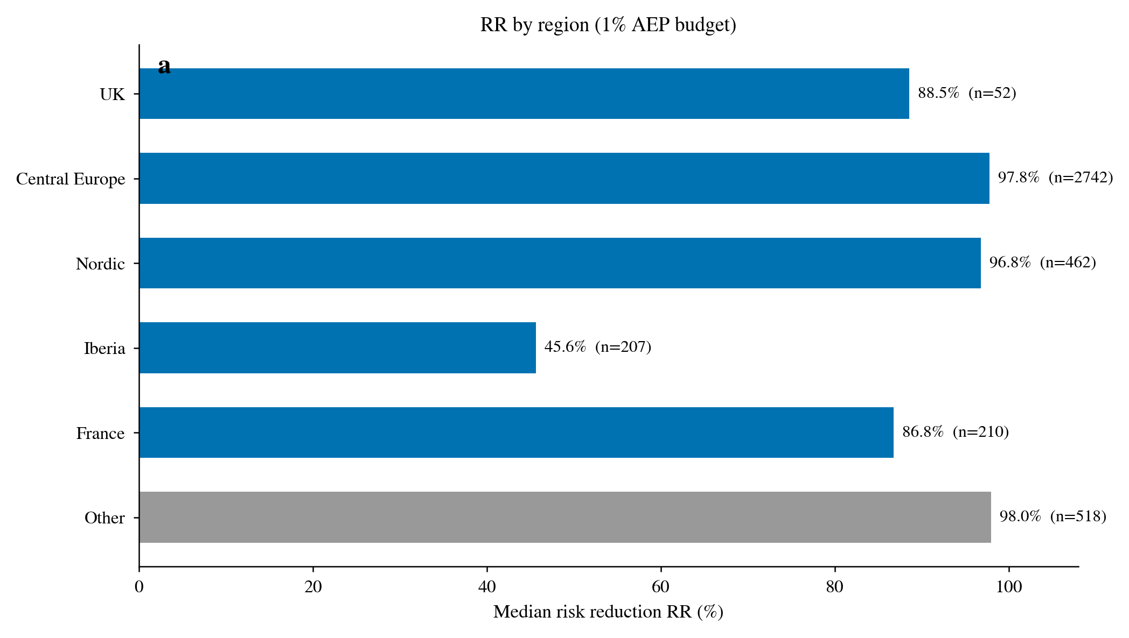
Figure S7.17 | Median RR by region (1% budget). Iberia is weaker; all other regions exceed 85%.
S7.18 AEP-budget extension sweep
The main-text trade-off is given only under four budgets, 0.5%/1%/2%/5%. Here we extend the budget to eight levels from 0.1% to 20% and recompute the median exposure reduction RR at each. The median RR rises monotonically with budget and saturates rapidly (Figure S7.18): 0.00% at 0.1%, already 80.03% at 0.5%, 99.07% at 2%, and 99.28% at 20%. Even an extremely low budget (0.5%) achieves about 80% exposure reduction, confirming that 'a large exposure reduction at very small energy cost' is robust across the budget dimension.
Table S7e | AEP-budget extension sweep (S7.18). RR is the median/mean exposure reduction.
Budget (%) | Median RR (%) | Mean RR (%)
0.1 | 0.00 | 24.73
0.25 | 46.06 | 48.13
0.5 | 80.03 | 67.21
1 | 96.94 | 82.57
2 | 99.07 | 90.29
5 | 99.26 | 93.19
10 | 99.28 | 93.59
20 | 99.28 | 93.71

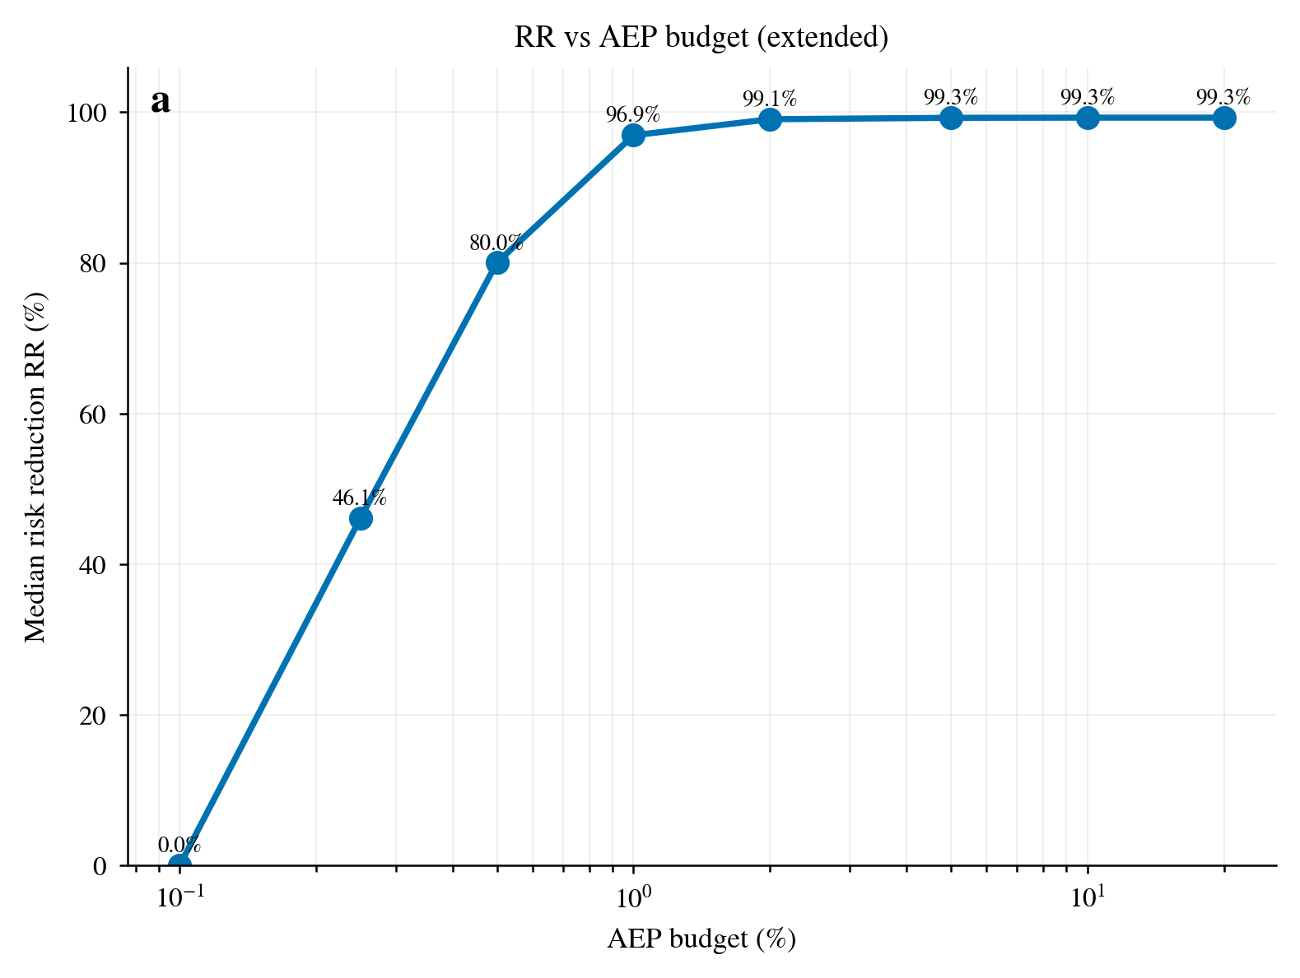
Figure S7.18 | AEP-budget extension sweep (logarithmic x-axis). Median RR rises monotonically with budget and saturates rapidly.
S7.19 Continuous concentration-weighting sweep (λ)
S7.5 has shown that concentration weighting and equal weighting differ negligibly, and S7.15 that the spring/autumn single-season decomposition makes no difference. Here we generalise 'how the two seasons are weighted' to a continuous parameter λ ∈ [0,1]: E(θ) = λ·sin²(θ − sd) + (1 − λ)·sin²(θ − ad), where λ = 0/1 is pure autumn/spring single-season and λ = 0.5 is equal weighting; the main-text convention is concentration weighting. At a 1% budget, the median RR goes from 97.88% at λ = 0 to 97.77% at λ = 1, staying within 96.97%–97.88% throughout and barely varying with λ (Figure S7.19). This agrees with S7.5/S7.15: the specific form of the seasonal weighting does not change the core conclusion.
Table S7f | Continuous concentration-weighting sweep (S7.19). λ = 0 pure autumn, λ = 1 pure spring; λ = 0.5 equal weighting.
λ (spring weight) | Median RR (%) | Mean RR (%)
0.0 | 97.88 | 82.55
0.1 | 97.59 | 82.42
0.2 | 97.38 | 82.37
0.3 | 97.13 | 82.38
0.4 | 97.03 | 82.45
0.5 | 96.99 | 82.52
0.6 | 96.97 | 82.63
0.7 | 97.02 | 82.75
0.8 | 97.16 | 82.91
0.9 | 97.38 | 83.21
1.0 | 97.77 | 83.64

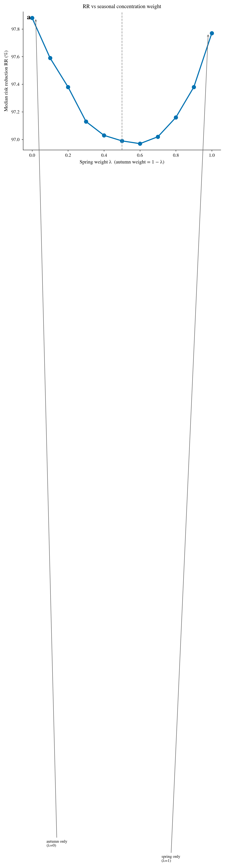
Figure S7.19 | Continuous concentration-weighting sweep (λ). Median RR barely varies with λ; λ = 0/1 correspond to pure autumn/spring single-season.
Supplementary Section S8 — Supplementary figures
This section gathers supporting figures beyond the main text and S1–S7: an overview of the argument chain, per-farm trade-off scatter and distributions, and additional figures — AEP vs exposure comparison, direction structure, size robustness and the migration direction field — added to reinforce the core conclusions.
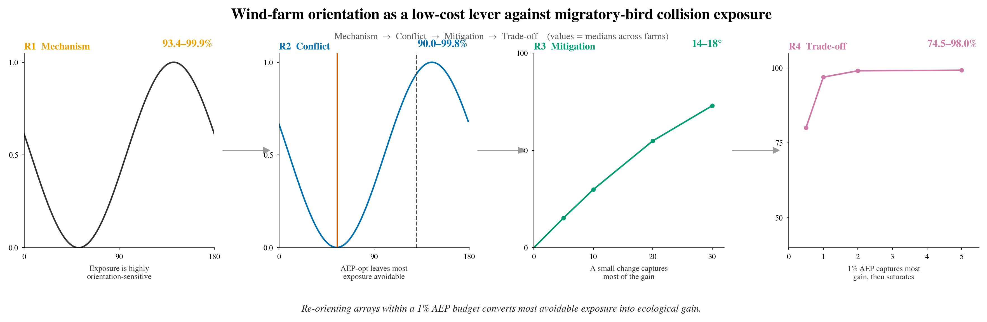
Figure S8.1 | Overview of the argument chain (graphical-abstract-style framework figure). The complete argument chain from migration direction making exposure highly orientation-sensitive, through the energy-optimal orientation retaining avoidable exposure, to a finite rotation and very small energy cost recovering most of the avoidable exposure.
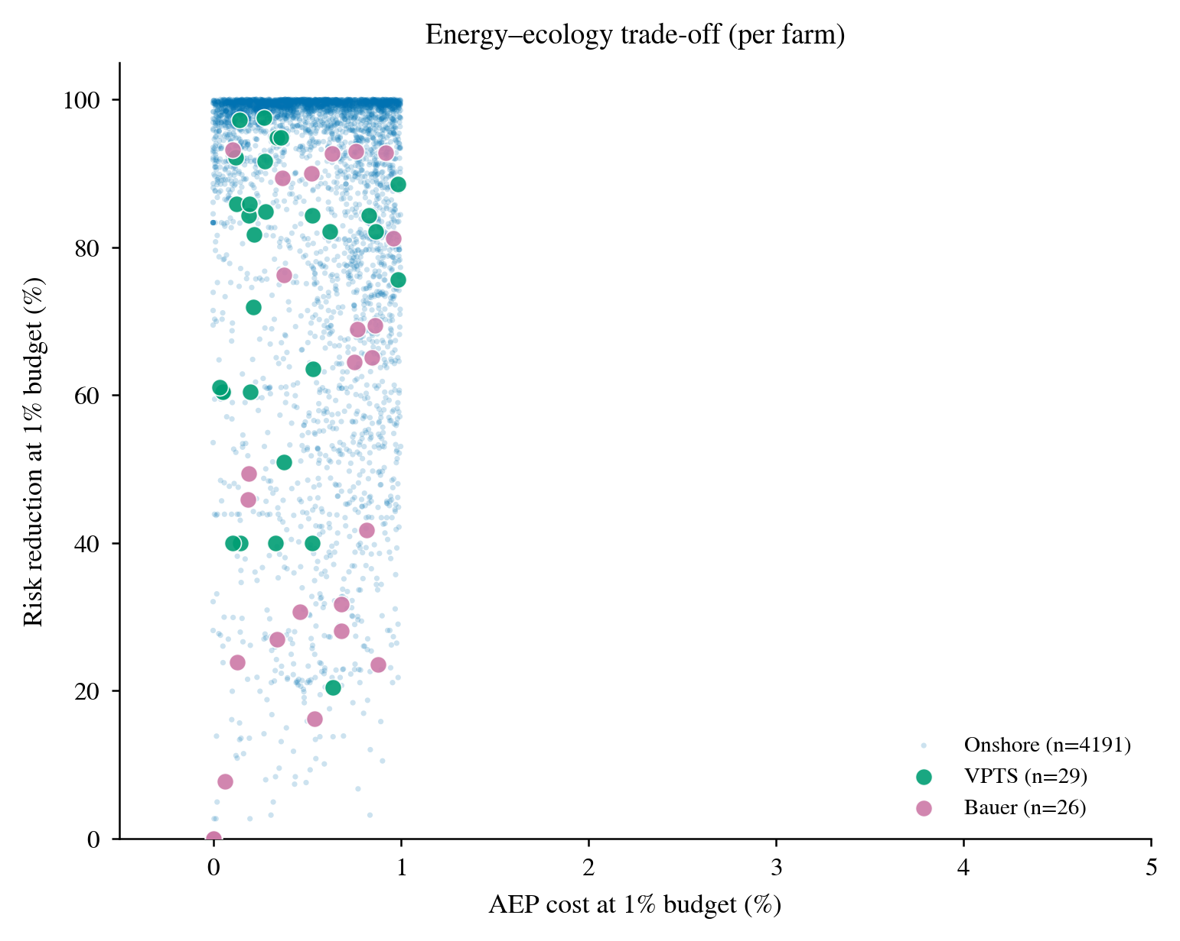
Figure S8.2 | Per-farm energy–ecology trade-off scatter: AEP cost against exposure reduction RR at a 1% budget (three groups). The vast majority of farms achieve large exposure reduction at <1% energy cost.
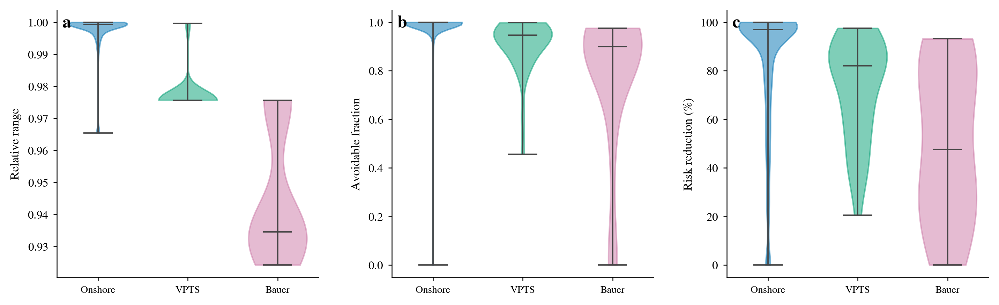
Figure S8.3 | Distributions (violins) of rel / avoid / RR for the three groups. All three groups consistently show high sensitivity and high avoidability.
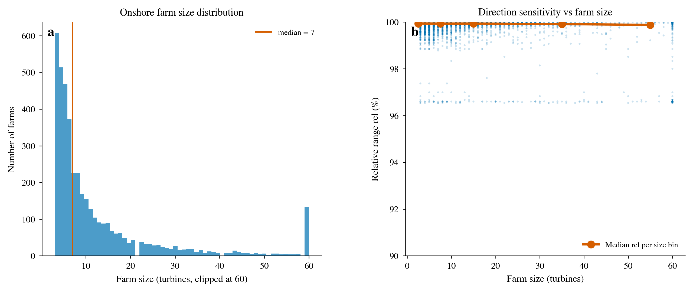
Figure S8.4 | Onshore farm size: distribution and orientation sensitivity. (a) Farm size distribution (turbine count, truncated at 60, median marked); (b) orientation sensitivity rel against farm size (scatter + binned-median line). Sensitivity does not depend on farm size.
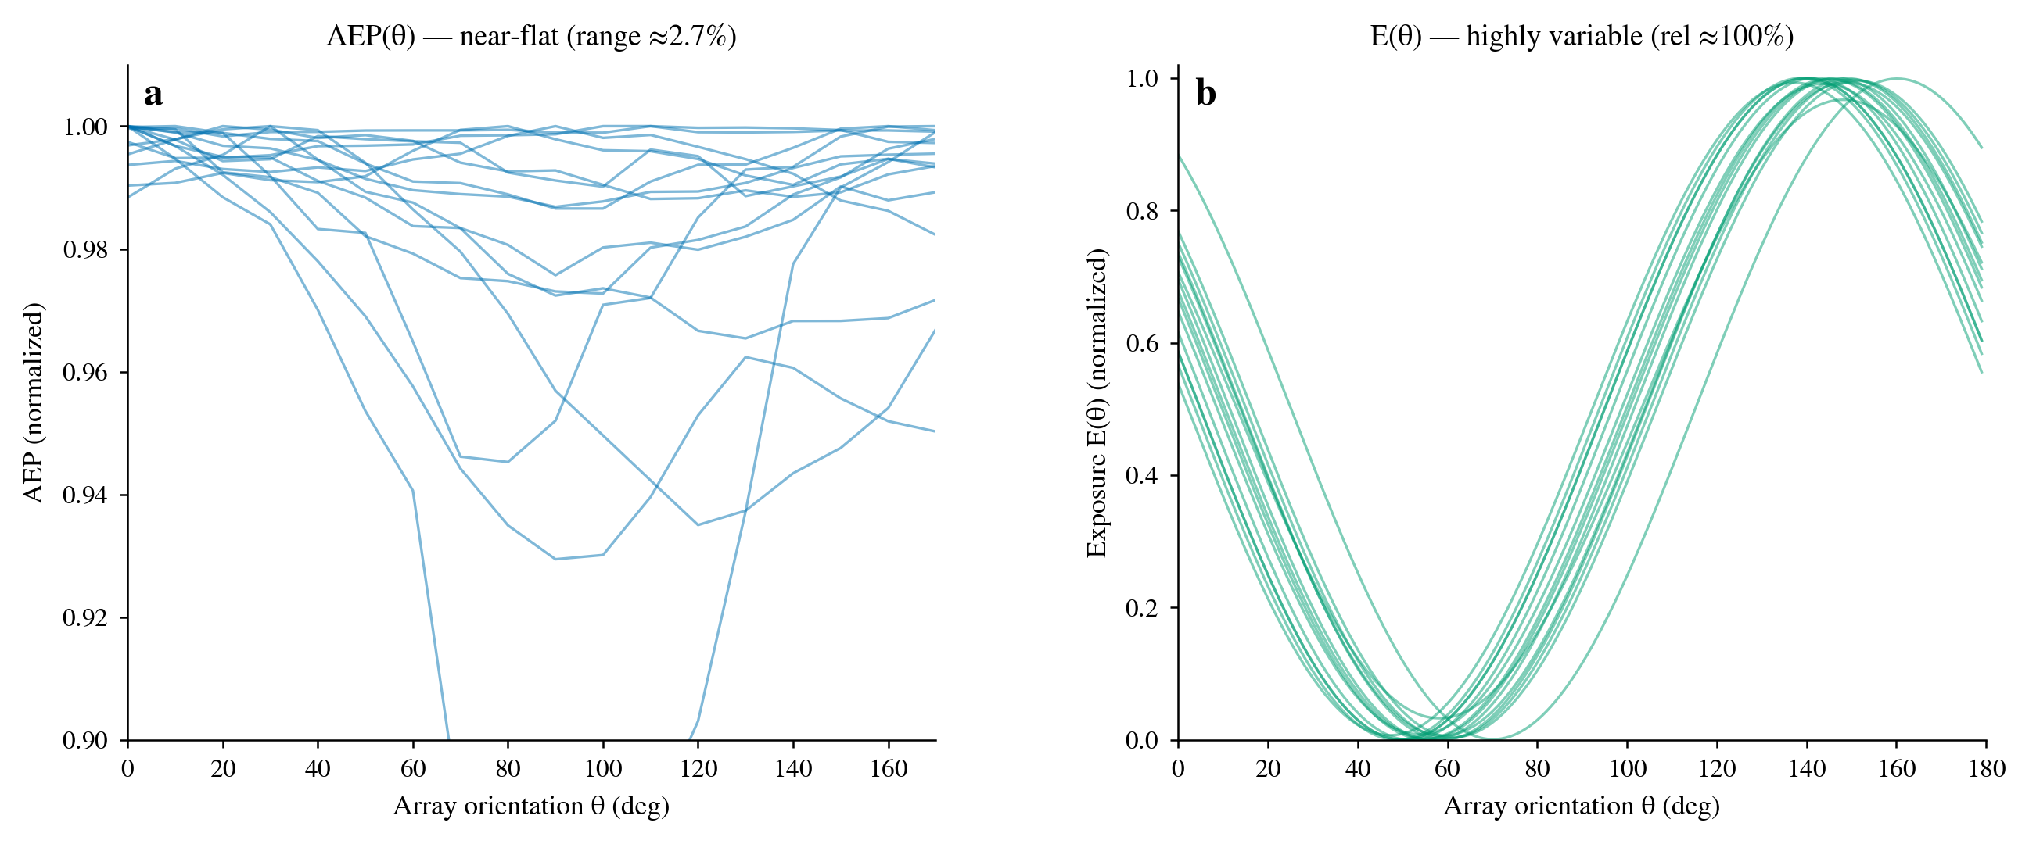
Figure S8.5 | Flat AEP vs sensitive exposure (direct visualisation of the core argument). (a) Normalised AEP(θ) curves of 15 representative onshore farms (cross-orientation variation ≈2.7%); (b) normalised exposure E(θ) curves of the same 15 farms (rel ≈100%). The two differ by two orders of magnitude in cross-orientation variation, the physical basis of 'large exposure reduction at very small energy cost'.
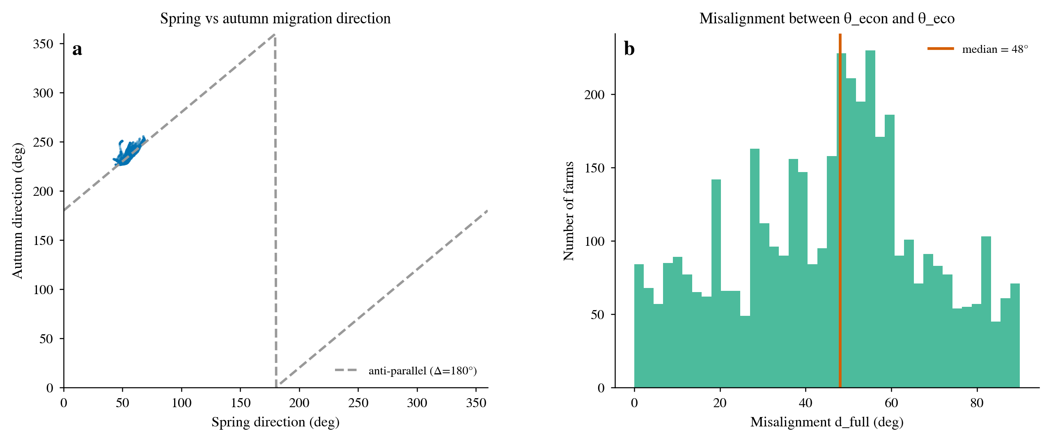
Figure S8.6 | Migration direction structure and misalignment angle. (a) Spring/autumn direction scatter of the 4,191 onshore farms, with the anti-parallel reference line (Δ = 180°) dashed; (b) distribution of the energy-optimal vs ecology-optimal misalignment angle d_full (median 48°).
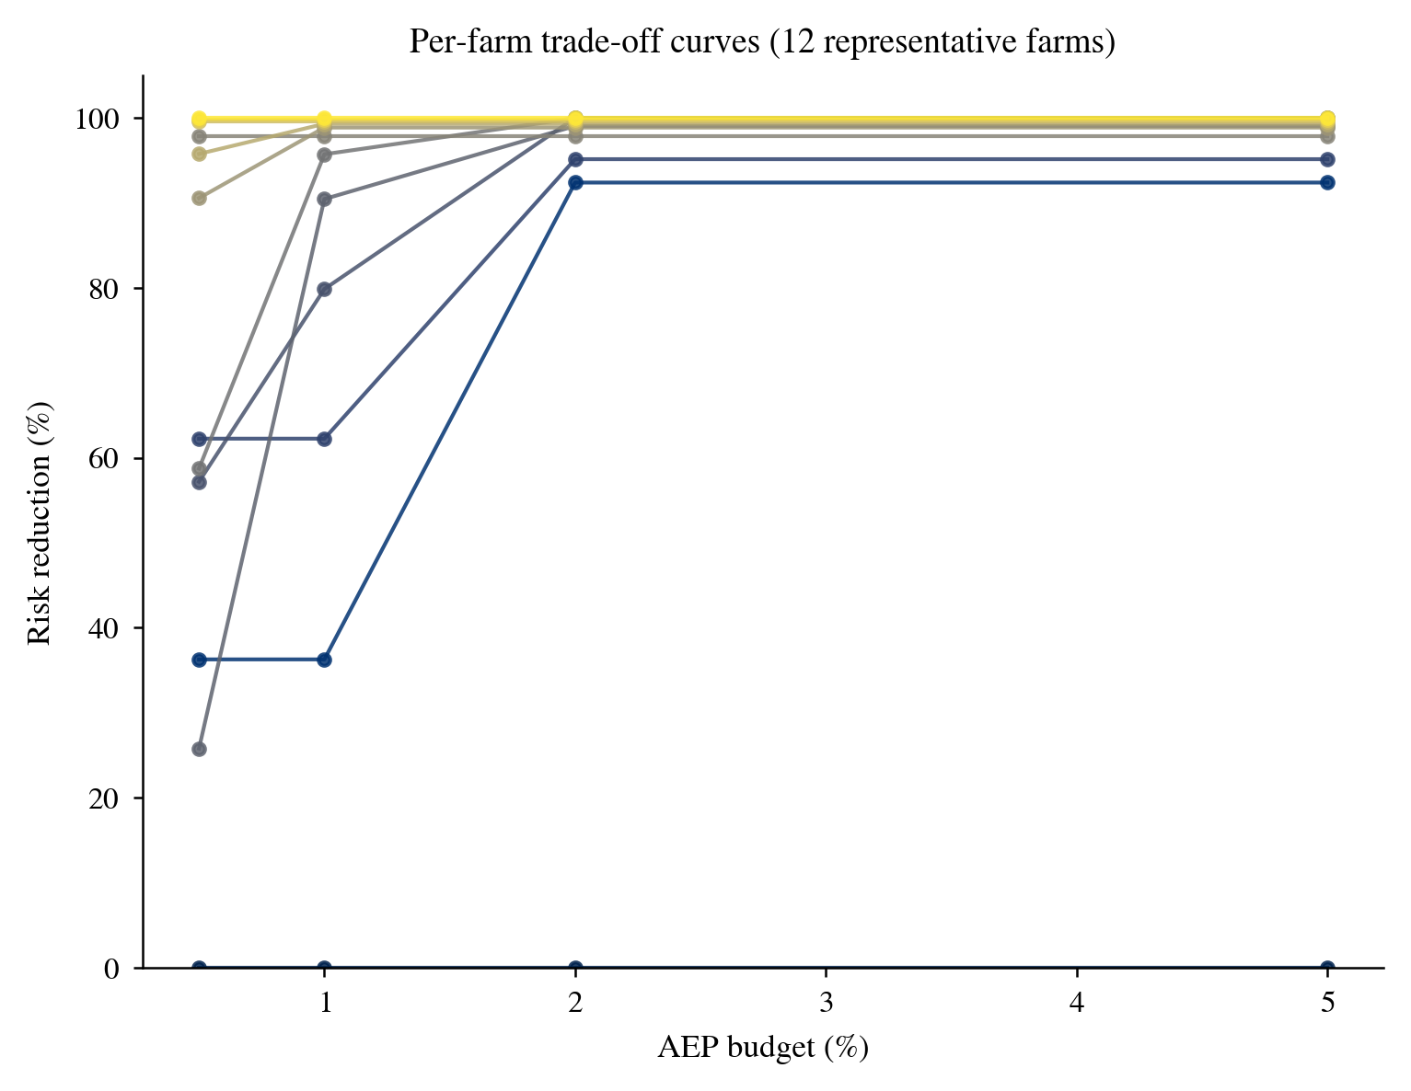
Figure S8.7 | Per-farm trade-off curves of 12 representative onshore farms (exposure reduction RR against AEP budget), showing rapid saturation as the budget grows.
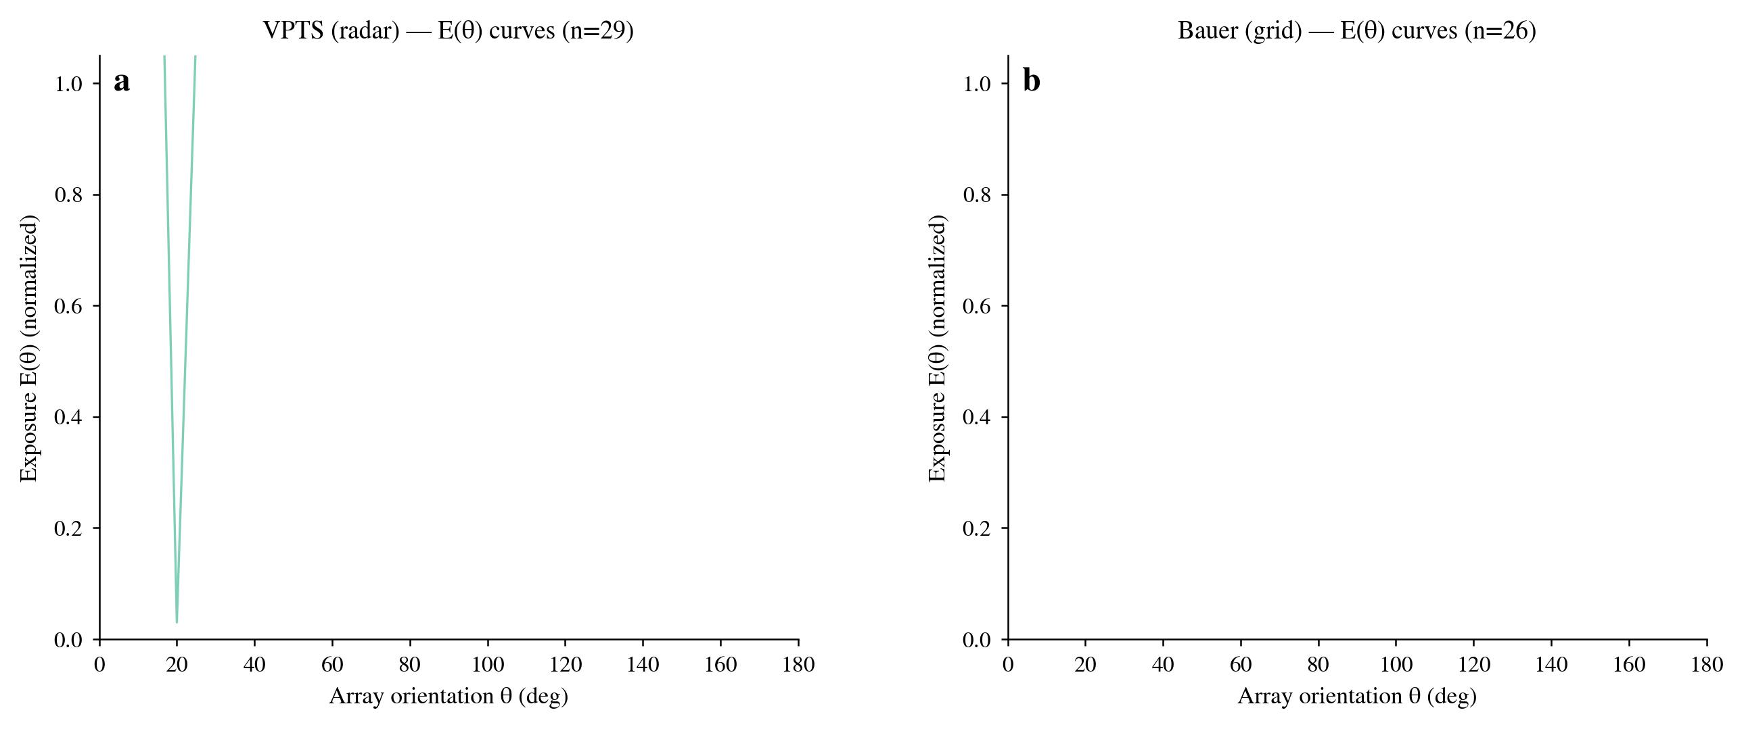
Figure S8.8 | Offshore exposure-curve samples. (a) VPTS (radar) 29 farms; (b) Bauer (grid) 26 farms. Exposure is highly orientation-sensitive under both conventions.
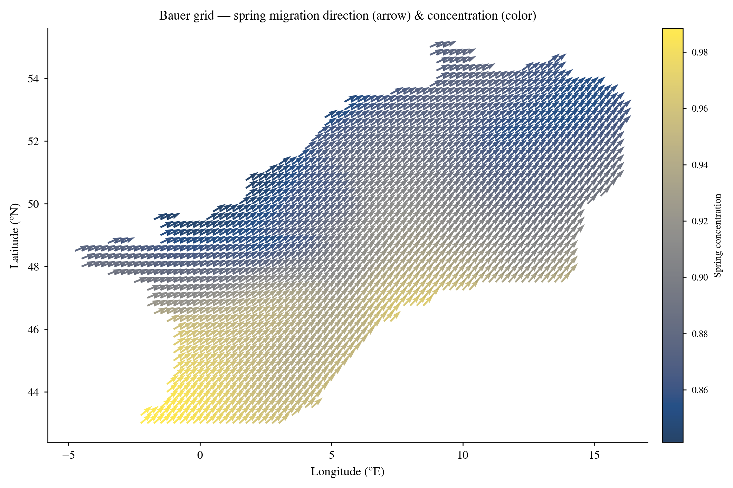
Figure S8.9 | Bauer-grid spring migration direction field (arrow = direction, colour = concentration). The stable southwest-to-northeast migration axis corroborates the spatial structure of the onshore direction inputs.
Supplementary Section S9 — Scope-and-assumptions ledger
Table S9a consolidates every core assumption of the study, labelling each as either 'scope definition' or 'modelling approximation', and gives (where determinable) its direction of effect on the core result (onshore median exposure reduction ≈96.9%). Assumptions that have been sensitivity-tested have a corresponding S7.x subsection; scope-definition assumptions do not constitute a testable perturbation but define the quantity this study estimates in the first place.
Table S9a | Scope-and-assumptions ledger (S9).
Assumption | Class | Direction on core result | Note / test
sin² geometric model, no behavioural avoidance | scope definition | defines the estimand | screening quantity, not mortality
No mortality/avoidance calibration | scope definition | no absolute collision claim | only relative cross-orientation change compared
Onshore Jensen wake model | modelling approximation | understated penalty overstates favourability | S7.1, S7.2
Offshore FLORIS wake model | modelling approximation | engineering grade, directionally reliable | S7.13
GWA wind resource (climatological mean) | modelling approximation | neutral (long-term mean) | no interannual variation
DBSCAN/PCA farm definition | modelling approximation | weak | S7.6, S7.12
200-km Bauer match radius | modelling approximation | weak (plateau from ≥150 km) | S7.7
Bauer direction convention | data convention | explains VPTS/Bauer difference | S7.4
Seasonal concentration weighting | data convention | negligible | S7.5
Offshore 29/26-farm small sample | sampling | widens offshore RR confidence interval | S7.14
Spring/autumn single-season vs concentration weighting | data convention | negligible | S7.15
Onshore rotor/hub/capacity defaults (70 m/70 m/2 MW) | modelling approximation | weak (RR shift ≤0.12 pp) | per-turbine missing 71.0%/69.4%/42.7%; farm-level on default 1.6%/1.5%/32.1%; S7.16 swept

The robustness of the core conclusion rests on two points. First, the relative change of exposure with orientation is set by the geometry and does not depend on the absolute exposure level or on any behavioural assumption (Properties 1–6). Second, the energy cost is set by the wind rose and the ecological gain by the migration axis, and the two are almost decoupled (S7.10, S7.13). Therefore, although individual assumptions carry uncertainty bands, no reasonable perturbation of any single assumption changes the qualitative conclusion of 'a large exposure reduction at very small energy cost'. This study advances a relative, geometric-screening conclusion and makes no numerical claim of absolute collision-mortality reduction.
Data and code availability, limitations and factors not covered
To ensure reproducibility, Table S10 lists the main data files used in this analysis and their contents. All files are intermediate/final data of this project; the generating scripts and parameters are fully specified in the main-text Methods and in S2.2–S2.5. Apart from the public sources (OSM, GWA, KMI, Bauer), no data beyond the main text are introduced.
Table S10 | Main data files and contents (for reproducibility checking).
Data file | Content
global_wind_farms.csv | Global wind-farm inventory (context and coverage)
osm_turbines_by_farm.csv | Onshore per-farm turbine coordinates and attributes
osm_farm_pca_orientations.csv | Onshore farm PCA principal-axis directions and explained-variance ratios
onshore_aep_curves.csv | Onshore per-farm AEP(θ) curves (18 orientations)
onshore_tradeoff_results.csv | Onshore per-farm energy–ecology trade-off (four budgets)
all_171_exposure_curves_corrected.csv | Offshore 171-farm exposure curves E(θ)
offshore_farm_directions_55.csv | Offshore 55-farm bird directions (VPTS 29 + Bauer 26)
tradeoff_offshore_55farms.csv | Offshore per-farm energy–ecology trade-off
bauer_grid_cell_directions.csv | Bauer-grid 2,025-cell migration direction and concentration
radar_station_signatures_v3.csv | VPTS radar-station per-season signatures (density/flux/direction)
sensitivity_summary.json | Summary numbers for all 13 S7 sensitivity analyses
bootstrap_ci.json | Bootstrap 95% confidence intervals for the S7.14 core trade-off metrics

For byte-level reproduction, Table S10b gives the byte size and SHA-256 checksum (the content fingerprint at generation time) of each data file; any later change alters the checksum, so it can be used to verify that a file version matches the analysis reported here.
Table S10b | SHA-256 checksums and byte sizes of the data files (fingerprint at generation time).
Data file | Bytes | SHA-256
global_wind_farms.csv | 6,898,037 | a446c4c3d0dadff951645fb203a33e0bdf2c828a7509486fe3ad6153fe1dcce0
osm_turbines_by_farm.csv | 3,713,909 | aebf7038f08a5dd16eac8ccee283a2c85331a0a4485cb92f41807fc06968cf4d
osm_farm_pca_orientations.csv | 448,212 | 61d8c9b91952b8c27aa7712d12d28793e679508619331cee579091150d28df4d
onshore_aep_curves.csv | 1,599,658 | f2a3895611e1d16f4ca52a57ac1f40e11838908f43b0046f0aa13bed818e87a4
onshore_tradeoff_results.csv | 2,537,643 | 5e93e4452a1ef2c39b3051088a2fc1ae231b17561ec3b75ff6c58a5f4ce43335
all_171_exposure_curves_corrected.csv | 172,278 | 40bd371d39329c1d59fa84502f372ac5fcf8c6064d477cfab32aab1e90124c97
offshore_farm_directions_55.csv | 2,936 | b69679cda52c9bf9de2724a4d686b1dc736dc5157d7d1b2dcf1492dbe3965174
tradeoff_offshore_55farms.csv | 37,919 | a05cd1f93ac37d049e54ee6c2d411d27eada27fb6c3156eeacc663297be70db5
bauer_grid_cell_directions.csv | 125,109 | 78221cd53c61a7c830d5905cf08ba69281caa711faacd9b3b7fe656b87c30686
radar_station_signatures_v3.csv | 639 | c9657ec7623737d99fce781d126a32838b032d72bbec2ab5655622336d795d52
sensitivity_summary.json | 5,189 | ebef449c05318ff1e8a8644f325a91541b97027f330755178d115c535e2349e3
bootstrap_ci.json | 1,505 | fe17cb8dc6ae622390b11817b805b9afca666ca1d2a529a308763aa3a8863617

Code availability: all analysis and figure-generation scripts accompany this project in our_work/scripts/, including figure_style.py (the convention entry point compute_metrics()), onshore_aep_computation.py (onshore AEP), generate_supplementary_figures.py (all figures of this Supplementary Information), sensitivity_*.py (the S7 sensitivity analyses), bootstrap_confidence_intervals.py (the S7.14 confidence intervals) and build_supplementary_docx.py (assembly of this document). The script parameters are fully specified in S2.3–S2.6 and reproduce every number.
Factors not covered: the sensitivity analyses here are single-factor (one assumption perturbed at a time); no multi-factor joint Monte Carlo is performed, so the joint envelope of the assumption uncertainties may be narrower or wider than the sum of the single-factor intervals. Country stratification is unavailable because the OSM country field is 76% missing and its non-empty values are manufacturer fragments rather than ISO codes, and is therefore dropped by prior agreement (S7.11). In addition, calibration to absolute collision mortality (flight-height/rotor-sweep overlap × avoidance rate × mortality) lies outside the scope of this screening study. These limitations are noted correspondingly in the main-text Discussion.
Supplementary References
[1] Jensen, N. O. A note on wind generator interaction. Risø-M-2411, Risø National Laboratory (1983).
[2] Katić, I., Højstrup, J. & Jensen, N. O. A simple model for cluster efficiency. In European Wind Energy Association Conference and Exhibition (1986).
[3] National Renewable Energy Laboratory. FLORIS: FLOw Redirection and Induction in Steady State. https://github.com/NREL/floris.
[4] Global Wind Atlas. https://globalwindatlas.info.
[5] OpenStreetMap contributors. https://www.openstreetmap.org.
[6] Bauer, S. et al. Migration flyways and bird collision risk for European wind energy. Zenodo, 10.5281/zenodo.17960034 (2026).
[7] Koninklijk Meteorologisch Instituut (KMI). Open Data — weather radar (2020).
[8] Hersbach, H. et al. The ERA5 global reanalysis. Q. J. R. Meteorol. Soc. 146, 1999–2049 (2020).
[9] Global Energy Monitor. Global Wind Power Tracker. https://globalenergymonitor.org.
[10] CAFF. Arctic Migratory Birds Initiative — Flyways. Arctic Biodiversity Data Service.
[11] BirdLife International. AVISTEP: Avian Sensitivity Tool for Energy Planning.

